Meath Public Participation Network

Nomination Form

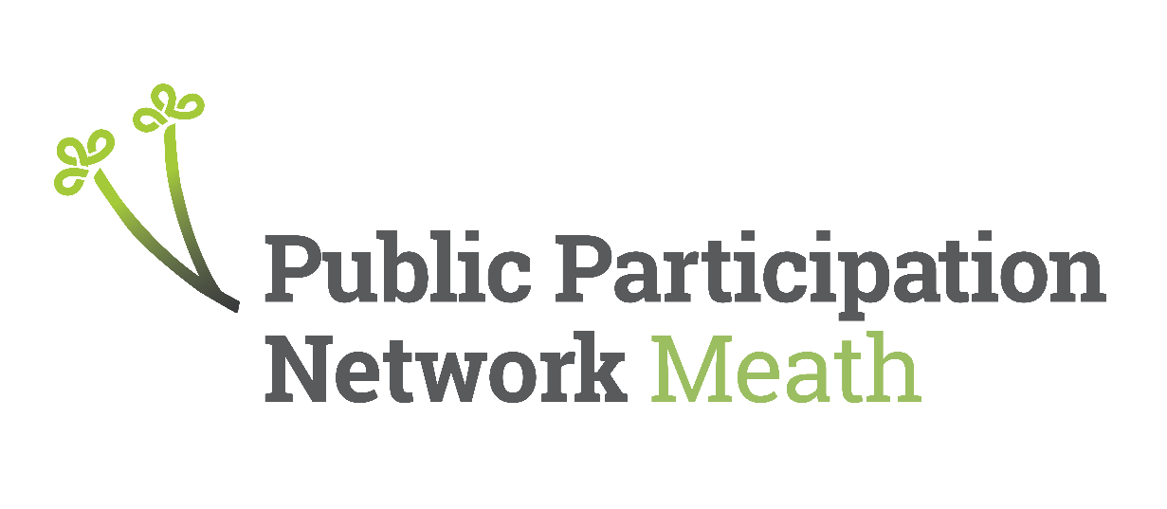

Secretariat Vacancies:
(Please tick relevant MD or Pillar)

☐ Ashbourne MD

☐ Laytown/Bettystown MD
☐ Community/Voluntary
☐ Social Inclusion

Deadline: 5pm Friday 27th February 2026
Meath Public Participation Network: Secretariat Nomination Form
Please complete this form in full and in BLOCK CAPITALS.
1. Name of Nominee
2. Organisation/Group of Nominee
3a. MD of Nominee Group (Ashbourne or Laytown-Bettystown)
3b. Pillar of Nominee Group (Community or Social Inclusion) leave blank if only seeking MD position
4. Contact Details of Nominee
Address
(Including Eircode)
Email
Mobile
Phone
5. What is the position you are being nominated for?
Secretariat
6. Have you read the brief associated with the position you are nominated for?
7. Do you understand the role you are nominated for?
8. Do you know of any potential conflict of interest in taking on this role?
9. Can you commit to the role you are nominated for?
10. Candidate Statement (Up to 150 words) This will be circulated to members ahead of an election. State why you may be the most suitable candidate for the role.
11. I agree to abide by the purpose, values and principles of Meath PPN.
Signature |  |  |  | Date
12. Authorisation from Organisation of Nominee (Authorised Officer)
This nomination must be authorised by a proposer and seconder of the nominee’s organisation. This should include the Chairperson or Secretary of the organisation. If these positions are held by the nominee, the names below must be other members of the organisation.
Name 1
Position
Mobile
Email
Signature
Name 2
Position
Mobile
Email
Signature
Thank you. Please submit fully completed forms by:
Email: meathppn@meathcoco.ie or
Post: Nicky McDonnell, Meath PPN, Buvinda House, Navan, Meath C15 Y291
For further enquiries email meathppn@meathcoco.ie
Incomplete forms will be deemed invalid.

