Property Marking Scheme
Information for Event Organisers
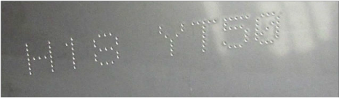
County Council’s EIRCODE
on a metal sheet
• The machine works by stamping your Eircode
into the item to be marked, using a series of dots.

• The depth and size of the dots is adjusted to suit the material to be marked, e.g. plastic, wood, carbon fibre.
It’s VERY IMPORTANT that the correct pattern is selected for the material - too strong a stamp could damage the item to be marked.

• The machine CANNOT be used to stamp items made of GLASS, as glass will shatter. Many smart phones are made of glass, so take care to examine these carefully before attempting to mark them.

• The owner of the property is agreeing to having their property marked. It is important that the responsibility for checking that the correct pattern is selected for the material to be marked rests with the owner. We recommend that you get the owner to confirm the material to be marked and check the pattern you have selected before each item is marked. We recommend also that you make clear that no liability can be accepted for damage caused.

• Every household and premises in Ireland has its own unique EIRCODE. If the owner of an item does not know their EIRCODE, you can look it up on the website www.eircode.ie. Enter their townland and use the map to zoom in on their house. Place the red circle over the house and click to find the 7-digit code for the house.

• We recommend that you hold community events in a location with good internet coverage, and that you have access to a tablet or other device, so that you can help people look up their EIRCODE if necessary during the property marking event.

• If you are bringing the system out to an individual’s premises, we recommend that you ask them to complete the property log book in advance of your visit. This will help them to assemble the information you will need in advance, and will help to shorten your time on site.

• We have prepared a one-page flyer explaining the scheme to the householder/ user. This explains the basics of the stamping process, and also that signs and stickers are available to purchase for them to display as a deterrent to would-be thieves.

• You should display this information at your event, or hand it out, to assist in explaining the process to your clients.

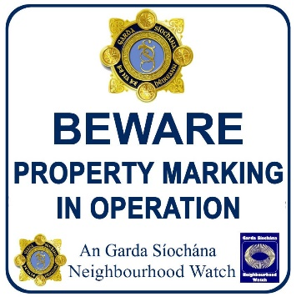
PRICING

• Meath County Council does not charge for loaning out the Telesis machine.

• We do reserve the right to ask a group to repair or replace in the event of any damage to the machine, but apart from that, it is free to use.

- There is a charge for the signs & stickers which can be used with the scheme. These are
not compulsory, but they do add value, as they draw a would-be thief’s attention to the
fact that the item is marked, and thus may deter the thief from going through with a theft.

- The pricing is structured to cover print costs and also to allow a small amount to be held back by your group. So, as you are marking property, you are raising funds for your group.

- The signs and stickers are available to buy from Sureprint in Tipperary. Only GROUPS are to contact Sureprint - please don’t give individuals the order details!

- When a person has their property marked, bring their attention to the availability of stickers and signs. If they wish to avail of these, show them the price list and have them fill out the appropriate order form.

- We ask that you wait until you have completed all marking in your area and returned the machine, then place one global order for all stickers and signs. This makes managing the order easier for Sureprint.

- The signs and stickers are available in a range of sizes, to suit all premises and items.

- There are two order types - one for private households, and one for commercial premises. There are different price rates for the household and commercial orders: as commercial users can claim the expenditure back as a business expense, the charity which set up the ’community protect’ sign scheme that we are using for this initiative has decided that they should pay a little more.

- A property log book is also available, to record details of the items which have been marked. This is useful to have filled out in advance of a visit to a premises, as it saves you time on site if the owner has already examined their equipment and figured out what material it is made from, found out what their EIRCODE is, and gathered all the items to be marked into one place.

TIPS FOR A SMOOTH EVENT
- To speed things up, mark all items which are made of the same material and are to be stamped with the same EIRCODE one after another. This saves having to switch between the patterns.

- It is therefore worth your while to spend a minute organising a person’s items to be marked before starting. Group them into plastics, metal, etc. Then you can get started.

- To make looking for EIRCODES easy, have a tablet or laptop or something with a large screen to hand. Smartphones are too fiddly if you have to look for an address by following a road on a map - too much panning and screen freezing!

FINALLY
- It’s important that we build up a picture of how the scheme is spreading across the county.

- Please return the form supplied when you are returning the Telesis machine.

- Once 50 premises have been covered in your area, we will erect 4 signs. If you wish to have more erected, you can fund those out of the funds raised from your sale of stickers etc. We will be happy to put them up for you.

CONTACT DETAILS FOR BORROWING THE PROPERTY MARKING SYSTEM
- The Property Marking Scheme is managed through the Community Dept of Meath County Council. The machine will only be loaned on foot of an advance booking.
- Due to the high demand for the machine, the maximum time that the machine can be loaned to any one group is one week. However, a group may borrow the machine more than once, if demand allows.
- Contact the Community Dept on 046 9097416 or meathcsp@meathcoco.ie

