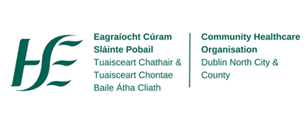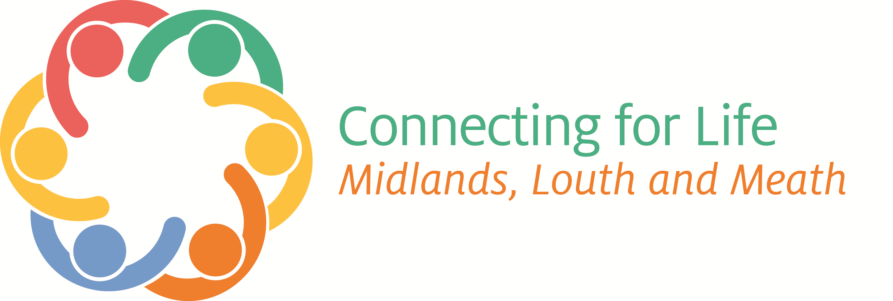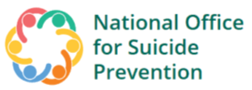
HSE LOUTH MEATH
Suicide Behaviour Awareness & Self-Harm
Training Programmes
January to April 2023

Online Training Programmes:

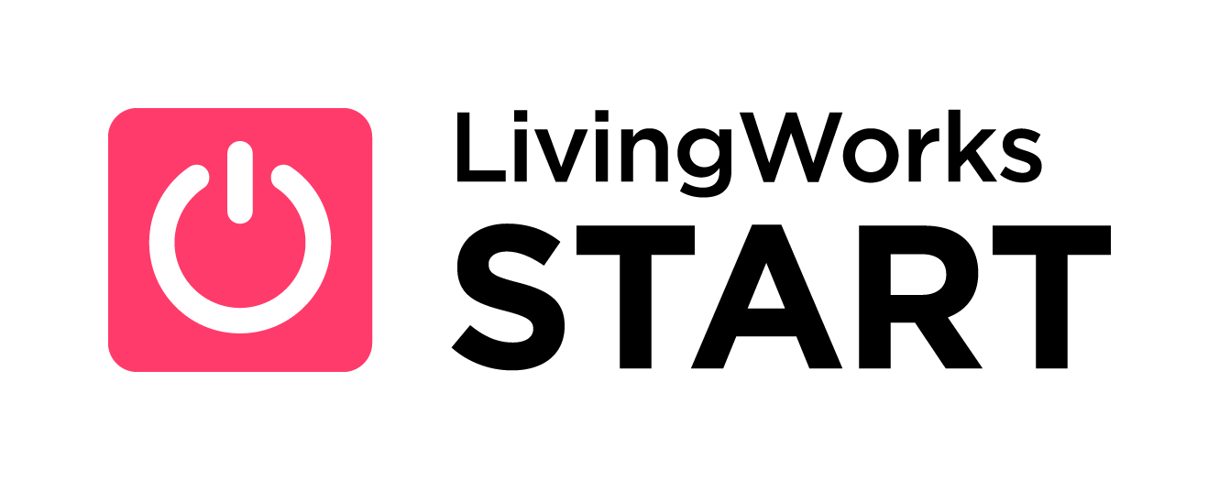
LivingWorks Start is targeted at anyone over the age of 18yrs who wants to help prevent suicide and develop the skills to assist someone who may be at risk of suicide. It can be completed in 1½ hours and includes a four-step model and impactful simulations which are undertaken and put into practice during the programme.
The programme provides the opportunity for participants to:
- Become more comfortable talking about suicide
- Feel more confident in keeping a person safe in times of distress
- Be able to support members of the community, friends and co-workers
- Build personal and professional skills
- Have peace of mind knowing the readiness to help is obtained
- Gain awareness of the supports and services that are available.

A free access licence is required to undertake the programme and this can be obtained by registering on:
https://bookwhen.com/suicidepreventiontraininglouthmeath - queries to: rosaleen.dolan@hse.ie


An ‘Introduction to Self-Harm’ (2 hrs) programme is suitable for those aged 18yrs and over who seek to develop their knowledge and understanding of self-harm. The programme aims to clarify what self-harm is and the causes, motivations and functions are discussed. Information on how to support and care for those engaging in self harm and the resources and services that are available is given. The next scheduled online facilitated programme is on Thursday, 2nd of February at 10am. Register by clicking the link below: https://bookwhen.com/suicidepreventiontraininglouthmeath

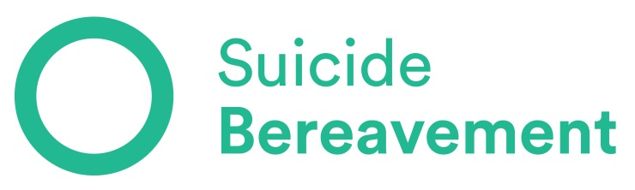

Face to Face Training Programmes:



SafeTALK is a half-day alertness training that prepares attendees, regardless of prior experience or training, to become a suicide-alert helper. Most people with thoughts of suicide don’t truly want to die, but are struggling with the pain in their lives. Through their words and actions, they invite help to stay alive. SafeTALK-trained helpers can recognise these invitations and take action by connecting them with life-saving intervention resources. Participants learn how to provide practical help by using the steps of TALK (Tell, Ask, Listen and Keepsafe) and also gain information on the supports and resources available locally, regionally and nationally.
The four basic steps of TALK (Tell, Ask, Listen and Keepsafe) are called ‘suicide alertness skills’ and are taught with the expectation that the person learning them will use them to help save lives and reduce suicide risk in their community. Information and registration process to attend scheduled workshops is available on: https://bookwhen.com/suicidepreventiontraininglouthmeath
Date and Time | Venue
18.1.23 at 2pm | The Bungalow 15 Wellington Ave, Trim, C15FC03
7.2.23 at 9.30am | Navan Education Centre, Athlumney, Navan, Co. Meath
18.4.23 at 10am | Kells Family Resource Centre,
Individual settings based safeTALK Workshops can be delivered upon request to groups with a minimum of 12 participants – contact rosaleen.dolan@hse.ie

Understanding Self-Harm (USH)
This 1 day workshop provides opportunities for improved knowledge, awareness and understanding of self-harming behaviour. Participants consider how personal attitudes and experiences might affect their helping role with a person who self-harms. The programme aims to clarify what self-harm is, what leads people to engage in self-harming behaviour and considers its relationship with suicide. The causes, motivations and functions of self harm are discussed. Positive approaches to engaging with, caring for and supporting someone who engaged in self-harm behaviour are presented. Active participation is encouraged.
DVD clips containing contributions from service providers and individuals with lived life experience of self-harm supplement the programme. Information and registration process to attend scheduled workshops is advised on: https://bookwhen.com/suicidepreventiontraininglouthmeath
Date and Time | Venue
18.4.23 at 9.30am | Navan Education Centre, Athlumney, Navan, Co. Meath

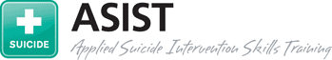

A.S.I.S.T. (Applied Suicide Intervention Skills Training) is a 2-day skills based, intensive, interactive and practice-dominated Workshop designed to help Caregivers recognise the immediate risk of suicide and learn how to respond and be in a position to provide immediate safety, help and information to individuals whose lives may be at risk.

A.S.I.S.T. is designed to help all Caregivers become more ready, willing and able to help persons at risk of suicide. The Workshop has five learning sections:
  - Preparing - sets the tone and expectations of the learning experience.

  - Connecting: – sensitises participants to their own attitudes towards suicide.
Creates an understanding of the impact which attitudes have on the intervention process.

  - Understanding: – overviews the intervention needs of a person at risk.
Focuses on providing participants with the knowledge and skills to recognise risk and develop safe plans to reduce the risk of suicide.

  - Assisting: – presents a model for effective suicide intervention. Participants develop their skills through observation and supervised simulation experiences in large and small groups.

  - Networking: – generates information about resources in the local community. Promotes a commitment by participants to transform local resources into helping networks.
Information and registration process to attend scheduled workshops is advised on: https://bookwhen.com/suicidepreventiontraininglouthmeath
Date and Time | Venue
22.3.23 & 23.3.23 | Navan Education Centre, Athlumney, Navan, Co. Meath

To register on any of the above programmes, log onto https://bookwhen.com/suicidepreventiontraininglouthmeath
or contact the HSE Resource Officer for Suicide Prevention as listed below:
Louth/Meath
Rosaleen Dolan: Email: rosaleen.dolan@hse.ie or Mobile: (087) 2165846

