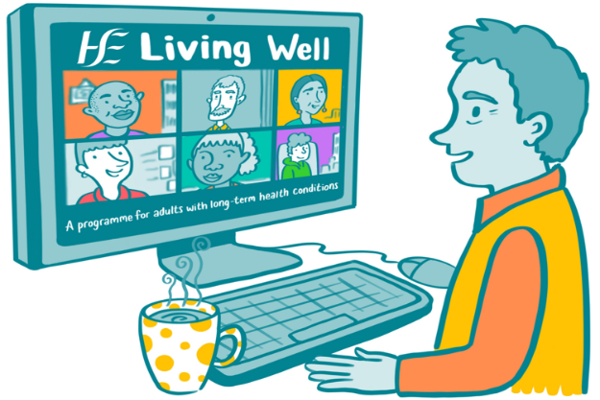
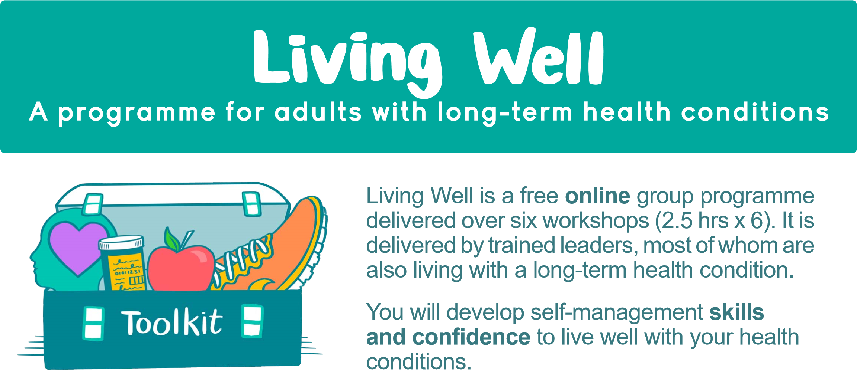
Upcoming Living Well Programmes
Day | Start date | Finish date | Time
Tuesday | 24th January 2023 | 7th March 2023 | 10.30am – 1pm
Thursday | 26th January 2023 | 9th March 2023 | 10.30am – 1pm

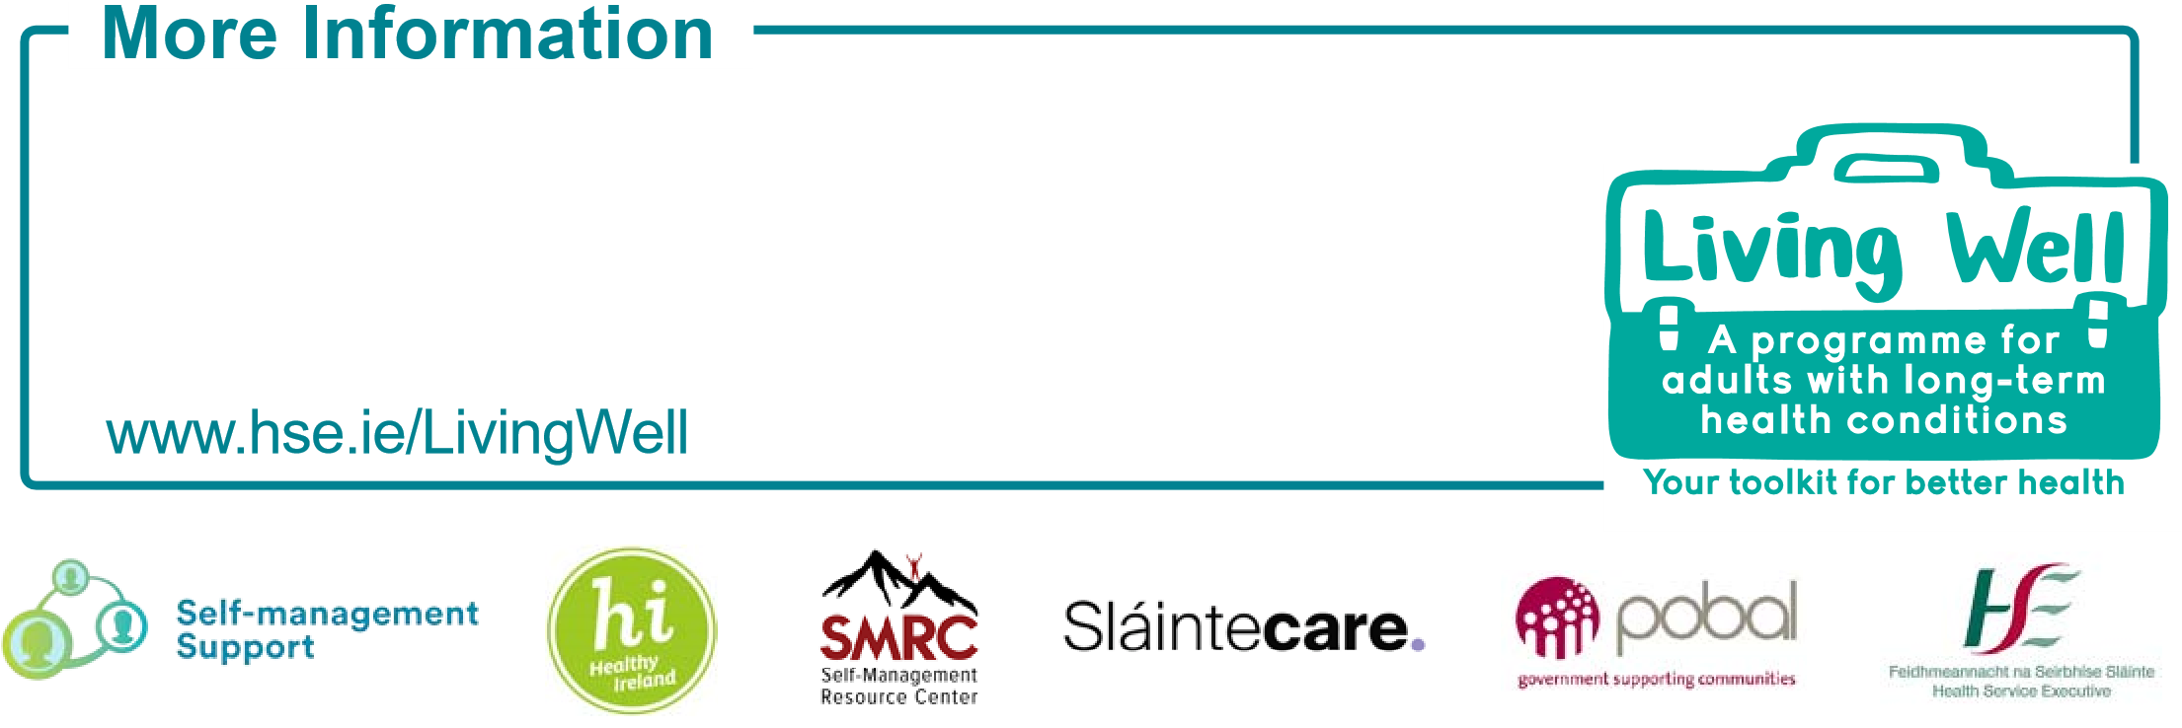
To book your place contact
- Aine McNamee – Living Well Co-ordinator
Aine.mcnamee@hse.ie / Tel: 041 6850676 or 087 1140371

- Joanne Farrelly – Living Well Administrator
Joanne.farrelly@hse.ie / Tel: 041 6860710 or 087 4308735
Aine McNamee on 0871140371 or 0416850676 or email aine.mcnamee@hse.ie

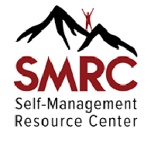
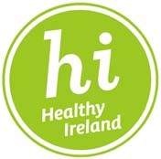
Long-term health conditions include (but are not limited to) COPD, asthma, diabetes, stroke, heart conditions, multiple sclerosis (MS), arthritis, cancer, Crohn’s disease, chronic pain and depression.

This is an SMRC Evidence Based Self-Management Programme originally developed at Stanford University.

