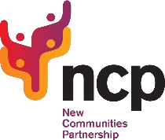

NCP MIGRANT NATIONAL FORUM
Thursday 26th May 2022
6pm-8pm

AGENDA

6pm-6.05pm | Introduction/Platform Instructions & Rules | Laura Twagirayezu  Outreach & Support Worker
6.05pm-6.10pm | Welcome Remarks | Cherif Labreche  NCP CEO
6.10pm-6.20pm | NCP Migrant National Forum Presentation | Francesco De Salvia  National Development & Integration Officer
6.20pm-6.30pm | NCP Migrant Dublin Forum Presentation | Nasser Aidara  SICAP Community Development Coordinator
6.30pm-6.45pm | Social Media & Effective Engagement | Sevak Khachatryan  Communication & Public Relation Officer
6.45pm-7.30pm | Workshop 1:  Identifying & Addressing Engagement  Barriers and Obstacles | Zoom Room 1  Facilitator: Nasser
6.45pm-7.30pm | Workshop 2:  Networking & Collaboration | Zoom Room 2  Facilitators: Laura & Francesco
6.45pm-8pm | Workshop Resume and Q&A | Panel
8pm | Closing Remarks | Bashir Otukoya NCP Board  Member

