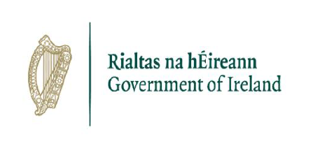

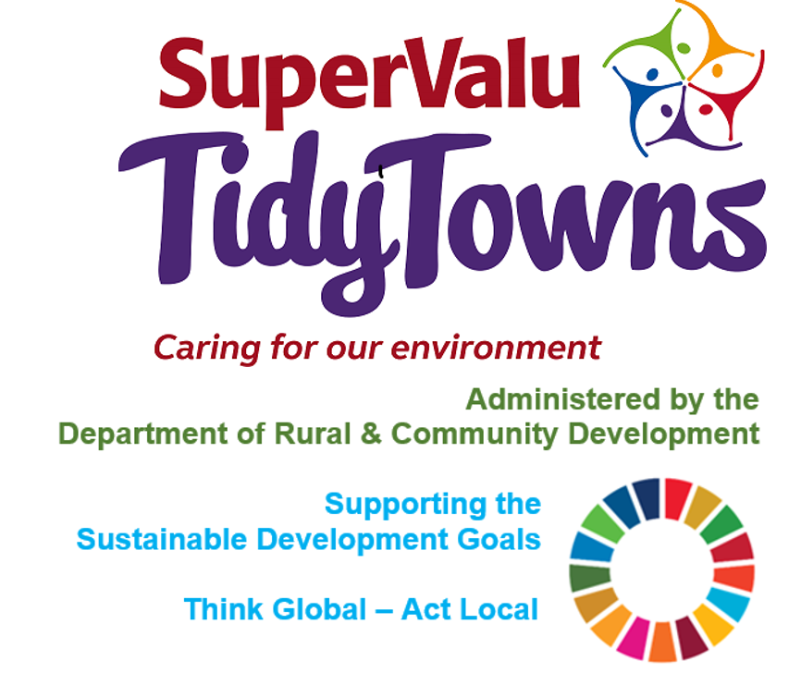

<https://www.facebook.com/OfficialSuperValuTidyTowns>



[Description: Description: Description: https://encrypted-tbn2.gstatic.com/images?q=tbn:ANd9GcTn6e_yvEEKZGqngkOvFQKXiE5grEl9MBv8f3BIJGAnDVia4IA6BMWDw64](https://www.google.ie/url?q=https://about.twitter.com/press/brand-assets&sa=U&ei=gIVOU7azCeed7Qafq4DoCw&ved=0CC4Q9QEwAQ&sig2=_2Ys344bv7jS9rXT1Izm4w&usg=AFQjCNEMyI7-tFvyJYa1KkCdXm5XILcS9g)   <https://twitter.com/TidyTownsIre>



<https://www.tidytowns.ie>

**Tidytown email**

[tidytowns@drcd.gov.ie](mailto:tidytowns@drcd.gov.ie)

**Newsletter**

<https://www.tidytowns.ie/about-us/newsletters/>.

**Handbook**

<https://www.tidytowns.ie/competition/handbook/>

**Minister Humphreys launches €7 Million Fund to develop community facilities & amenities in rural areas under CLÁR**

<https://www.gov.ie/en/policy-information/91ba52-clar/>

**Sustainable Development Goals (SDG’s)**

<https://sustainabledevelopment.un.org/post2015/transformingourworld/publication>

**SuperValu partners with the All-Ireland Pollinator plan for “Save the Bees” Campaign**

<https://supervalu.ie/real-people/save-the-bees>

<https://pollinators.ie/>

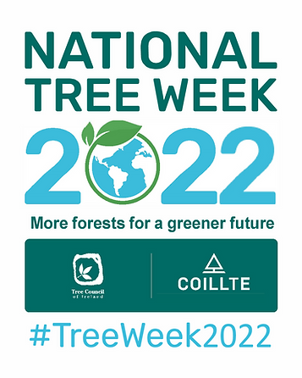**National Tree Week 2022**

<https://www.treecouncil.ie/woodland-walks>

<https://www.treecouncil.ie/national-tree-week>

**Alone – Free Digital Skills Training**

[www.alone.ie](http://www.alone.ie)

**Our Rural Future: Minister Humphreys launches €15 million Fund to support Outdoor Adventure Activities**

[oris@drcd.gov.ie](mailto:oris@drcd.gov.ie)

**Sustainable Energy Communities and TidyTowns.**

<https://www.seai.ie/community-energy/sustainable-energy-communities/join-the-sustainable-ener/>

[sec@seai.ie](mailto:sec@seai.ie)

**Blackwater TidyTowns - Seeds to Success**

<https://www.wexfordcoco.ie/community/healthy-wexford/healthy-wexford-initiatives/seeds-to-success-community-growing-series>

<https://www.facebook.com/HealthyWexford/videos/635291144416031/>

- <https://www.youtube.com/watch?v=uHBaPx4L12c>