

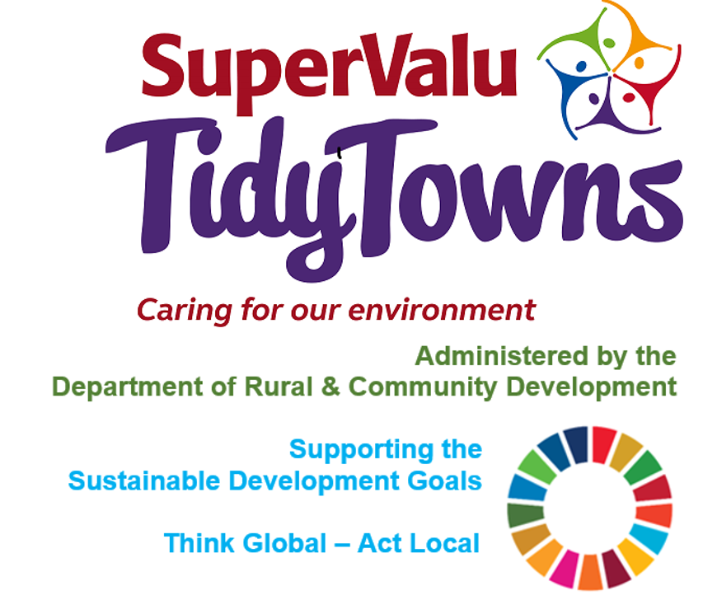

<https://www.facebook.com/OfficialSuperValuTidyTowns>



[Description: Description: Description: https://encrypted-tbn2.gstatic.com/images?q=tbn:ANd9GcTn6e_yvEEKZGqngkOvFQKXiE5grEl9MBv8f3BIJGAnDVia4IA6BMWDw64](https://www.google.ie/url?q=https://about.twitter.com/press/brand-assets&sa=U&ei=gIVOU7azCeed7Qafq4DoCw&ved=0CC4Q9QEwAQ&sig2=_2Ys344bv7jS9rXT1Izm4w&usg=AFQjCNEMyI7-tFvyJYa1KkCdXm5XILcS9g)   <https://twitter.com/TidyTownsIre>



<https://www.tidytowns.ie>

**Tidytown email**

[tidytowns@drcd.gov.ie](mailto:tidytowns@drcd.gov.ie)

**Newsletter**

<https://www.tidytowns.ie/about-us/newsletters/>.

**Handbook**

<https://www.tidytowns.ie/competition/handbook/>

**Castlebar TidyTowns – Floating Tree**

<https://fb.watch/aeVwwCNyOg/>

**Shane Holland Design**

<https://shanehollanddesign.com/>

**Healthy Ireland**

<https://www.gov.ie/en/campaigns/healthy-ireland/>

**Unwanted Gifts & Packaging**

[www.repak.ie](http://www.repak.ie)

**Our Feathered Friends**

<https://birdwatchireland.ie/>

<https://birdwatchireland.ie/irelands-birds-birdwatch-ireland/garden-birds/>