

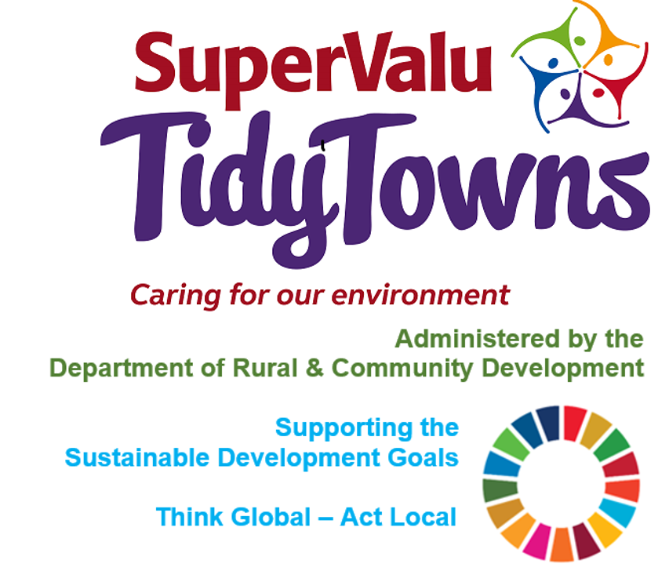

<https://www.facebook.com/OfficialSuperValuTidyTowns>



[Description: Description: Description: https://encrypted-tbn2.gstatic.com/images?q=tbn:ANd9GcTn6e_yvEEKZGqngkOvFQKXiE5grEl9MBv8f3BIJGAnDVia4IA6BMWDw64](https://www.google.ie/url?q=https://about.twitter.com/press/brand-assets&sa=U&ei=gIVOU7azCeed7Qafq4DoCw&ved=0CC4Q9QEwAQ&sig2=_2Ys344bv7jS9rXT1Izm4w&usg=AFQjCNEMyI7-tFvyJYa1KkCdXm5XILcS9g)   <https://twitter.com/TidyTownsIre>



<https://www.tidytowns.ie>

**Tidytown email**

[tidytowns@drcd.gov.ie](mailto:tidytowns@drcd.gov.ie)

**Newsletter**

https://www.tidytowns.ie/about-us/newsletters/

**Reports**

<https://www.tidytowns.ie/reports/>

**Registered Applications**

<https://www.tidytowns.ie/competition/registered-entries>

**National Outdoor Recreation Strategy Public Consultation**

<https://www.gov.ie/en/consultation/42e3a-public-consultation-on-a-national-strategy-on-outdoor-recreation>

**Placemaking Awards**

[excellenceinplacemaking@uli.org](mailto:excellenceinplacemaking@uli.org)

[www.cbre.ie/uli-placemaking-awards](http://www.cbre.ie/uli-placemaking-awards)

<https://www.cbre.ie/en/about-cbre/uli-cbre-excellence-in-placemaking-awards>

**Net Zero Carbon**

<https://www.carbonfootprint.com/calculator.aspx>

<https://footprint.wwf.org.uk/#/>

<https://stopfoodwaste.ie/>

<https://www.seai.ie/community-energy/sustainable-energy-communities/>

<https://climateoutreach.org/reports/how-to-have-a-climate-change-conversation-talking-climate/>

**Survey**

<https://supervalushoptalk.eu.qualtrics.com/jfe/form/SV_78JSPXEk6BZ9uh8>