FASN –STILL HERE FOR YOU
The Family Addiction Support Network (FASN) is a dedicated support service for Family members/ concerned persons who are impacted by loved one’s substance misuse.
In these extremely difficult times we are very aware of the challenges our service users will be dealing with so we have developed a safe and secure online communications platform in which we can support you.
With this in mind we are continuing to provide vital service’s in the form of
- One to one support sessions
- 5 Step Brief Intervention
- Health & Wellbeing support through Facebook (FASN)
- Counselling
- Family Support Groups – online peer led family support groups.
Join our weekly online meetings for Navan, Drogheda, Dundalk, Cavan and Monaghan. You must contact us for details and support to access the online services at the contact details below. Remember we are here to help and support you. (in accordance with Department of Health Guidance Level 5)
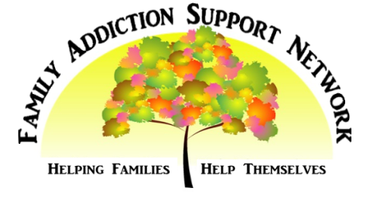
Call: 042-9355251 / 087-9046405 email: info.fasn@gmail.com

