

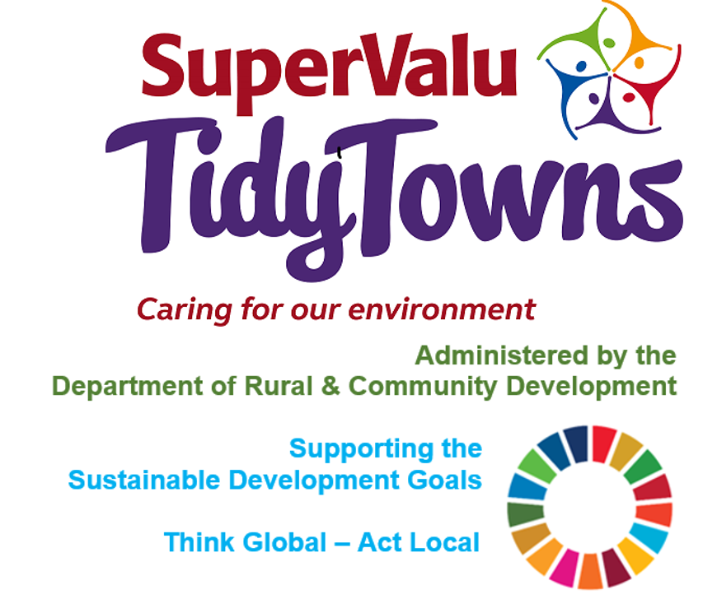

**Recycle**

[www.repak.ie](http://www.repak.ie)

**Pobal**

[tidytowns@pobal.ie](mailto:tidytowns@pobal.ie)

<https://www.facebook.com/OfficialSuperValuTidyTowns>



[Description: Description: Description: https://encrypted-tbn2.gstatic.com/images?q=tbn:ANd9GcTn6e_yvEEKZGqngkOvFQKXiE5grEl9MBv8f3BIJGAnDVia4IA6BMWDw64](https://www.google.ie/url?q=https://about.twitter.com/press/brand-assets&sa=U&ei=gIVOU7azCeed7Qafq4DoCw&ved=0CC4Q9QEwAQ&sig2=_2Ys344bv7jS9rXT1Izm4w&usg=AFQjCNEMyI7-tFvyJYa1KkCdXm5XILcS9g)   <https://twitter.com/TidyTownsIre>



<https://www.tidytowns.ie>

**Pollinator Plan- Sports Clubs**

<https://pollinators.ie/new-guidelines-published-to-help-sports-clubs-become-more-biodiversity-friendly/>

**Kilbride TidyTowns**

<https://m.facebook.com/kilbridetidytowns/>

**Ennis TidyTowns Fact Sheet**

<https://www.tidytowns.ie/about-us/newsletters/>

**Birdwatch**

[www.birdwatchireland.ie](http://www.birdwatchireland.ie)

[www.rspb.org.uk](http://www.rspb.org.uk)

**Tidytown email**

[tidytowns@drcd.gov.ie](mailto:tidytowns@drcd.gov.ie)