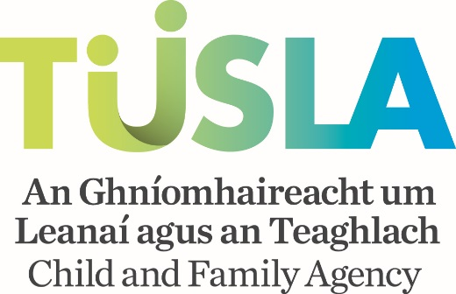

**Procedure for Drawdown of Tusla Participation Initiatives 2021**

Once an applicant has been approved for Tusla Participation Initiatives, the PPFS Senior Manager should note the following procedure to drawdown the funding.

**Projects Internally Managed**

The Tusla PPFS Senior Manager should arrange for invoices, staff reimbursement forms, procurement cards and any other form of expenditure relating to the project to be processed in their local area office in the normal manner, but using the Tusla Participation Initiatives cost centres, Parental Participation FC192882 or CYP Participation FC193883 . If your local staff have any issues in using these cost centres then they should contact the PO unit at [pounit@tulsa.ie](mailto:pounit@tulsa.ie) and they will be able to help. It is a condition of funding that a log of expenses against your project budget is kept and a template for this is attached. Copies should be sent by email to the National Finance Officer PPFS [finbarr.howard@tusla.ie](mailto:finbarr.howard@tusla.ie) by the last day of each month. Please keep a record of your spending for review meetings with Participation and Partnership Officers.

**Projects Externally Managed (funding to be made to C&V Sector)**

If the funding is to be paid to an organisation in the Community & Voluntary sector then an SLA must be completed. Where the C&V organisation has a pre-existing SLA then only a new part B in respect of the Tusla Participation Initiatives project needs to be completed on the Tusla Portal. If the C&V organisation does not have a pre-existing SLA then a part A and B will have to be completed. Please note as per the criteria on the application form individual grant payments to C&V organisations should not be lower than €1,000. If you require support in respect of accessing the Tusla Portal or completing the SLA please contact [commissioning@tusla.ie](mailto:commissioning@tusla.ie). Once the SLA has been submitted please email the appropriate person so they can go into the Tusla Portal and approve.

**Final Step**

Once the above is completed, the PPFS senior manager should complete and sign the attached Tusla Participation Initiatives grant payment template and send to the National Finance Officer PPFS [finbarr.howard@tusla.ie](mailto:finbarr.howard@tusla.ie) for processing. It is important to note that completing the SLA on the Tusla Portal does not automatically generate a payment.

**Please note that all projects must adhere to the Tusla financial and procurement regulations and these are available on the Tusla Hub.**

**Payment Dates**

Grant funding payments are made on a monthly basis and please note the below dates by which completed templates must be with National Finance Officer PPFS to allow payment to be made in a particular month.

