

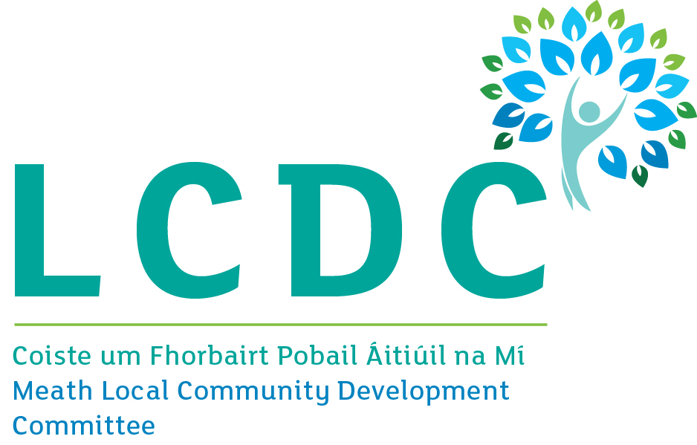

**Department of Rural and Community Development**

**COVID-19 Emergency Fund – Second Call**

**Guidelines**

**Please read the following guidelines carefully before completing the application form.**

1. **Introduction**

The COVID-19 Emergency Fund is a grant programme to provide funding to groups that are directly involved in the Community Call response to the COVID-19 pandemic.

It is funded by the Department of Rural and Community Development (*the Department*) and administered by the Local Authority (LA) in each area.

The Department provides funding to each LA area and the LAs then administer this funding locally to ensure funding is targeted appropriately.

The grants are for expenditure of a capital nature and operational costs related to the COVID-19 response work. Costs could relate to COVID signage, protective screening i.e. perspex, cleaning/sanitizing equipment and materials i.e. steamers, sprays, hand sanitizers, etc

It is intended that the majority of the funding that is allocated to each LA area will be ring-fenced for grants of €1,000 or less.

Applications can be made (by groups directly involved in the Community Call response) to the relevant LA.

**2. Who is eligible to apply?**

Groups that are directly involved in the Community Call response to the COVID-19 pandemic can apply.

Commercial organisations and individuals are not eligible for funding.

**3. What is eligible for funding?**

The funding covers capital type work related to the response to COVID-19. Operational costs directly attributed to Covid-19 supports outside of the normal running costs of an organisation will be considered. Costs could relate to COVID signage, protective screening i.e. perspex, cleaning/sanitizing equipment and materials i.e. steamers, sprays, hand sanitizers, etc

**4. What is NOT eligible for funding?**

The following expenditure is **not** eligible for funding:

* Any project not in keeping with the ethos of the Programme
* Any day-to-day expenses (i.e. normal operating costs)
* Employment costs
* Legal fees
* Private or commercial operations
* Insurance costs

**5. Requirements of the Programme**

The following conditions apply to all projects. Depending on the nature of your project (and the group applying), there may be further requirements that must be met. The LA will discuss this with you, if your application is successful.

**Tax Requirements**

* The applicant group/organisation does not have to be registered for tax purposes.
* Any applicant group/organisation that is registered for tax purposes must be tax compliant. In line with revised tax clearance procedures, which came into effect in January 2016, the Tax Clearance Access Number and Tax Reference number must be submitted for verification purposes.

**Statutory Consents -** Applicants must ensure that all necessary statutory permissions or consents have been obtained before any works commence, in cases where this is required. This includes but is not confined to planning permission.

**Insurance -** Written evidence of a valid insurance policy may be requested by the LA, where relevant, during the applications review process.

**Acknowledgment of funding** – The Department and Meath County Council should be acknowledged where possible.

**Match-funding** **-** this is not a requirement under this programme.

**6. Selection Criteria**

Applications will be evaluated by the Local Authority to ensure eligibility. Projects must be in keeping with the ethos of the programme, which is to provide funding to groups that are directly involved in the Community Call response to the COVID-19 pandemic.

The Local Authority will give priority to organisations which deliver frontline services.

Applications may be judged having regard to how they help in the response to the Covid-19 pandemic.

Projects may also be judged having regard to additional criteria deemed appropriate by the Local Authority which demonstrate the added value of the project or element of a project in suitably addressing the programme's aims in each LA administrative area.

**7. Corporate Governance**

**7a. Monitoring:**

Grantees will be required to comply with the highest standard of transparency and accountability as documented in Department of Public Expenditure and Reform Circular 13/2014 - Management of and Accountability for Grants from Exchequer Funds <http://circulars.gov.ie/pdf/circular/per/2014/13.pdf>

The overall principle is that there should be transparency and accountability in the management of public funds, in line with economy, efficiency and effectiveness. The circular outlines, for example, that grant recipients should not dispose of publically funded assets without prior approval.

**7b. The Code of Governance for Community and Voluntary organisations**

The Department is encouraging funded bodies to adopt the Governance Code, a Code of Practice for Good Governance of Community, Voluntary and Charitable Organisations, which will assist in achieving excellence in all areas of your work. The Governance Code asks organisations to agree to operate to key principles in order to run their organisation more effectively in areas such as leadership, transparency and accountability and behaving with integrity. Further information on the Code is available at [www.governancecode.ie](http://www.governancecode.ie)

**8. Approval Procedures**

All applications for funding under this programme received will be reviewed and assessed by each LA. Final approval will be made by the Local Community Development Committee (LCDC).

In deciding the final allocations of funding to projects, the LA may take account of a number of factors including geographical balance and the desirability to fund a variety of different projects. The Local Authority will give priority to organisations which deliver frontline services.

Following the decision each approved project, subject to the completion of legal formalities and other requirements, will receive an offer in principle of grant-aid. This will be subject to compliance with the relevant conditions and subject to the satisfactory acceptance by the applicant of that offer.

The right is reserved to reassign the funds offered to another approved project if all requirements are not met within a reasonable period.

The Department and/or the LA reserve the right to carry out an audit of expenditure or conduct inspections from time to time.

|  |
| --- |
| **Please Note:**  Requests for assistance usually exceed the funds available and it is important therefore that the process of evaluation is rigorous. The purpose of this process is to ensure that the best projects, taking all factors into account, emerge and receive support. It is Departmental policy to ensure that every application is treated fairly and impartially.  Offers of funding may be for a lesser amount than that sought by the applicant. Applicants should be aware that the Programme may be oversubscribed. Therefore, in such circumstances, all applications fulfilling the conditions may not be successful or may be for a lesser amount.  The LA in evaluating proposals received may seek advice and consult with other agencies, and may disclose information on projects under consideration to those experts and agencies. |

**9. General**

The information provided in this document is intended to give applicants an understanding of the process by which applications for funding are assessed and approved and does not purport to be a legal interpretation.

**Freedom of Information Act 2014**

Under the Freedom of Information Act 2014, details contained in applications and supporting documents may, on request, be released to third parties. If there is information contained in your application which is sensitive or confidential in nature, please identify it and provide an explanation as to why it should not be disclosed. If a request to release sensitive information under the legislation is received, you will be consulted before a decision is made whether or not to release the information. However, in the absence of the identification of particular information as sensitive, it could be disclosed without any consultation with you.

**Site Visits**

The Department or LA may carry out unannounced site visits to verify compliance with Programme terms and conditions.

**Further information may be requested**

The LA reserves the right to request further information from you in order to assess your application if so required.

**Usage of information**

The information provided on the form will be utilised for the purposes of evaluating and administering the grant process, and to facilities audits and any site visits. When evaluating the applications received the LA may seek advice and consult with other agencies, and may disclose information on projects under consideration to those experts and agencies.

**Other**

* Under the programme it is intended that the majority of the funding that is allocated to each LA area will be ring-fenced for grants of €1,000 or less.
* Applicant groups shall self-certify that they do not have the funding to undertake the work, without the grant aid, or alternatively that with the grant they will now undertake more work which they otherwise would not be able to afford.
* If the funding application is for one element of a project, applicants will be required to provide documentary evidence of the availability of the balance of funding for that particular element of that project.
* There is no limit on the number of applications for different projects from any organisation. However, applicants should be aware that an equity/fairness approach will be taken by the LA to ensure an even distribution of funding.
* The Programme is 100% exchequer funded. Applicants are free to leverage other funding/match funding for projects (e.g. with LEADER, Tidy Towns, Town and Village Enhancement funding, etc.) although that is not a requirement of this new programme.
* It is the responsibility of the administrators of/body responsible for any other funding scheme or programme to ensure that using this Programme to co-fund a project does not contradict the rules of that other scheme/programme.
* VAT will only be paid where it is included in the application amount. No further requests for VAT payments or repayments will be accepted.

**10. How to apply**

**Application Form**

The application form is detailed and is designed to ensure that it has the necessary information to evaluate each proposal accurately and fairly.

**Please ensure that you complete the COVID 19 Emergency Fund application form in full and that any documentation in support of your application is submitted with your application.**

Only projects that meet the criteria outlined above will be considered eligible.

Submission of false or misleading information at any stage is treated very seriously. Any organisation that does not comply with the terms and conditions of the Programme may be subject to inspection, have their grant withdrawn, be required to repay all or part of a grant and/or be barred from making applications for a period of time. All serious breaches of the terms and conditions of the Programme will be notified to An Garda Síochána.

**ALL APPLICATIONS TO BE RETURNED TO:**

[**communitygrants@meathcoco.ie**](mailto:communitygrants@meathcoco.ie) **or**

***Meath County Council,***

***Community Section,***

***Buvinda House,***

***Dublin Road,***

***Navan,***

***Co. Meath***

***C15 Y291***

**By 5pm on Thursday 12th November 2020.**

**Closing date will be strictly adhered to.**

Please direct your queries by email to [communitygrants@meathcoco.ie](mailto:communitygrants@meathcoco.ie) quoting Covid 19 Emergency Fund.

