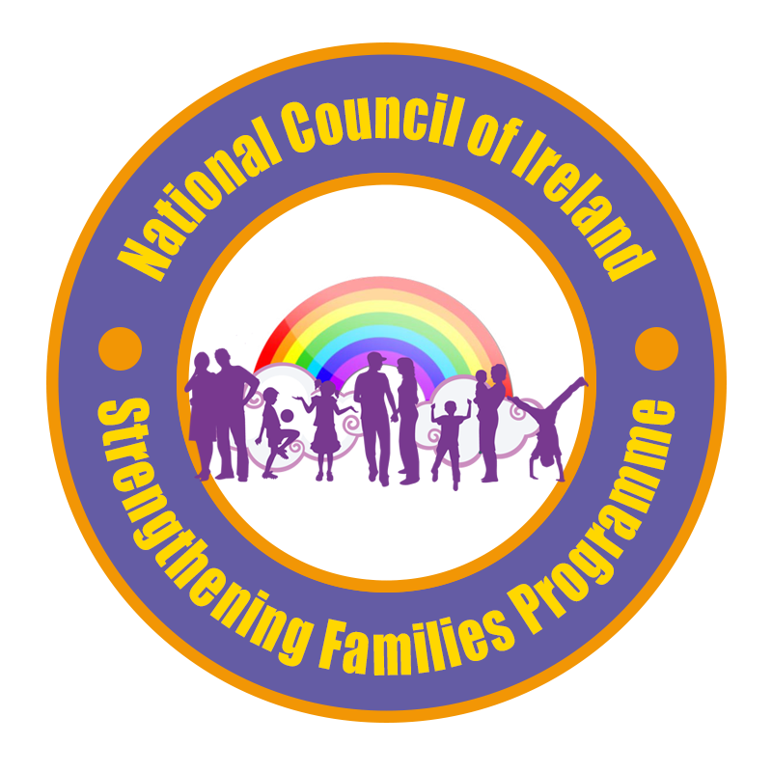



Strengthening Families Programme (SFP)
Training Application Form

10th and 11th September 2020
10am – 4pm (Both days)
Crown Plaza Hotel, Dundalk, Co. Louth

Please read the following carefully:
We are delighted to offer this opportunity of Strengthening Families Training for those interested in facilitating/delivering SFP. This 2 day SFP training is a necessary pre-requisite to being a Facilitator/Assistant Facilitator/Referrer on the Strengthening Families Programme.

Confirmed attendees MUST attend both days.

Please have your agency Manager/ Line Manager sign the agreement below, where applicable and relevant. Applicants will be trained up with the intention of facilitating/delivering the Strengthening Families Programme.

We value the quality of SFP and make every effort to maintain the highest standards possible for the families and team on the programme.
This 2-day training is a course in Strengthening Families, and not a training in facilitation.
:

Training will be delivered by:

Noel Loughran Sinead McCourt JLO Drogheda Garda station Deeside School Completion Programme
087-0601751 Ardee Community School

STRENGTHENING FAMILIES PROGRAMME TRAINING APPLICATION FORM

Training Dates: 10th and 11th September 2020

Location: Crown Plaza Hotel, Dundalk, Co. Louth

Name: ______________________________________________

Organisation: _______________________________________

Address: ____________________________________________

Contact Number: ____________________________________

E-mail: ______________________________________________

In what capacity are you involved in your organisation – paid employment/voluntary etc?
____________________________________________________________________________________________________________________________________________________________

Do you work with families directly? Y/N

In what capacity do you work with those families?
______________________________________________________________________________
______________________________________________________________________________
Do you work with Young People with drug/alcohol issues? Y/N

In what capacity do you work with those young people?
____________________________________________________________________________________________________________________________________________________________

Have you facilitated any programmes within your work? If so, could you name the programmes?
____________________________________________________________________________________________________________________________________________________________

Why do you wish to undertake the training?
______________________________________________________________________________
______________________________________________________________________________
Will your employer commit to you taking part in the delivery of a Strengthening Families Programme this year or in the future? Y/N

Are you currently Garda Vetted within your role? Y/N

The Strengthening Families adheres to the Children’s First Guidelines. Are you trained in Children’s First? Y/N

Please name any other relevant training/qualifications you have that may benefit the programme.

- ________________________________________________________________________
- ________________________________________________________________________
- ________________________________________________________________________
- ________________________________________________________________________

Do you have any special requirements in relation to the training days, diet, access etc…?

Signed: ___________________________________________________

Date: ___________________

To be signed by employer

- We (organisation) _____________________________ agree that the above person, following the training, may be involved in the delivery of a Strengthening Families Programme within Co. Louth.

We also understand, in order to maintain the integrity of the programme, that SFP must be delivered in its entirety and that the names SFP and Strengthening Families Programme are copyrighted to Karol Kumpfer and must be used under licence.

*Confirmed attendees must attend both days training in full and are expected to facilitate an SFP Programme in their area.*

Employer Signature ____________________

C. Volunteer Section Only:
All volunteers not employed by an agency must fill in the section below:

- Name of Agency/School you are linked with to volunteer and who can be contacted/updated: ____________________________________________________
Name Contact Person & Job Title: _____________________________________
Ph: ______________________ Email: __________________________________

- Proof of Garda Vetting must be demonstrated to Programme Manager, and a copy may be included with this application if you wish.

- Two written/verbal references (professional or academic) who may also be contacted.

1. Name: _________________________
Relationship to applicant: _________________________
Address: _________________________
_________________________

Phone: _________________________

2. Name: _________________________
Relationship to applicant: _________________________
Address: _________________________
_________________________

Phone: _________________________

Volunteer Applicants, please read the information below and sign:

I confirm that the above information is accurate, and I understand and agree to the terms set out above should I be accepted for a place on the training.

Signature of applicant: _______________________________ Date: ____________

Please Return Completed Form, before Friday 28th August 2020 at 5pm.

To:

NIAMH GRIMES
Project Worker | Deeside SCP

m. 087 2142660 | e. niamh.grimes@scp.ie
a. Scoil Ui Mhuiri, Dunleer, Co Louth

Please Note: Places on this training course are strictly limited due to Covid Restrictions and Social Distancing Guidelines.

Participants are asked to adhere to all Covid Regulations in place at the venue over the relevant 2 days.

Lunch will be provided on both days as well as Tea/coffee.

Free parking is available in the grounds of the Crown Plaza Hotel.

The Louth SFP Consortium wish to thank Louth Leader Partnership for providing funding for this training.

Extract from Ballymun SFP Handbook

- Facilitator / Assistant Facilitator / Floater

The Facilitators primary role is to deliver the Strengthening Families Programme in class-based sessions over 14 weeks, to parents and/or teens. An Assistant Facilitator is a support facilitator to the two Co-Facilitators and the SFP process in each of the Teens group. The Assistant Facilitator may also be asked to fill in for a Facilitator, in any of the group sessions, where a Facilitator may be unable to attend. A Floater is available every SFP evening for other supports that may be necessary, including general set up for the evening, welcoming families, facilitation needs as they arise, and is available to family members who may need to opt out of sessions throughout the evening.

The Facilitator or Assistant Facilitator or Floater will be trained in SFP, and comfortable and experienced working with groups (both adults and/or teens). Training in SFP can be accessed through attendance at courses organized in a number of different communities. Training can be made available locally when and as the need arises and depending on availability of SFP Trainers. The Programme Manager can be contacted regarding further information on training opportunities.

Volunteers: A volunteer who is associated with an agency/school/institution may apply to support SFP in one of the above roles. Volunteers should fulfill the same criteria as those listed below (as for Agency Representatives) and in particular should be Garda Vetted. Where an individual is not connected with an agency but wishes to volunteer, the Programme Manager will discuss possibilities for engaging with a volunteer structure. Please contact the Programme Manager if there are specific questions about volunteering.

Criteria:
A Facilitator/Assistant Facilitator/Floater is an agency representative or volunteer who commits a number of hours each week to the families to facilitate, engage, and contribute towards the development of the SFP.

- Has attended and completed the 2 day SFP Group Leader training.
- Has experience working with and facilitating groups of young people/parents/families.
- Has experience and/or knowledge of Children First Guidelines.
- Comfortable working with different family dynamics and groups.
- Comfortable working in a multi-agency setting and understand the dynamics of such methods of working.
- Available to facilitate on at least two programmes (each programme is one evening per week for 15 weeks, in Ballymun). (February – May &/or September – December)
- Has been Garda Vetted for the purpose of their current role, if an agency representative. Otherwise, volunteers must be linked with a volunteering body and Garda Vetted for the purposes of SFP.
- Has support from their (Line) Manager to engage with the Programme.
- Receives supervision or staff / volunteer support from their agency to include SFP.
- Can participate and commit fully to the programme including:
  - Facilitate a parent or children/teens group over the 15 weeks, and facilitate family sessions where agreed.
  - Attend induction meeting(s) (pre-programme) and evaluation meeting (post-programme).
  - Where possible, facilitators will be asked to attend the evaluation meeting for families to facilitate the administration of the questionnaire.

Facilitators will work with one or various groups depending on their role. Typically, Parent and Child/Teen Groups are assigned two co-facilitators per group, plus an Assistant Facilitator for each Child/Teen Group. Family groups are co-facilitated by one Parent and one Child/Teen Facilitator, with an additional Assistant Facilitator where necessary and resource permitting.
Example Weekly Sessions (12-16 yrs)*

3:00 – 4:00pm Briefing for Facilitators

4:00 – 6:00pm Co-Facilitators Preparation

6.00pm Arrival of Families

6.00-6.40pm Dinner - families and facilitators

6.40-7.30pm Parents & Children/Teens Group meet separately with respective Facilitators

7.30-7.40pm Break

7.40-8.30pm Family Skills - Parents and Children/Teens rejoin for Family Group with respective Facilitators

8:30-9:00pm Debrief with Facilitators

Roles and Responsibilities:

Meetings:
- Attend Team Building meeting(s) prior to programme start.
- Attend briefing meeting with Site Coordinator and other facilitators before the programme starts each evening (example 3pm/4pm).
- Attend debriefing session to review the evening’s events (example 8:30pm – 9pm).
- Attend review/feedback meeting post programme.
- Reconvene for Booster Session 6 months after families graduate.

Supervision/Support:
- The facilitator’s/volunteer’s agency is asked to provide supervision to include SFP.
- Where supervision is unavailable for SFP, the Site Coordinator / Programme Manager may provide informal support, where requested.
- If a further need arises directly from SFP, the facilitator should inform the Site Coordinator.
- The SFP MC encourages agencies to recognise and credit agency representatives with acknowledgement of the time given to the programme to support local families.
- To support Facilitators in their role, the SFP Management Committee requests that facilitators do not take on any additional or extra work related to the programme. Any queries, concerns or follow ups should always be brought to the attention of the Site Coordinator.

Planning and Preparation:

- Facilitators are given time before the programme on the night to prepare for the night and are asked to be present at the site of SFP from approximately 3pm. Facilitators finish at 9pm.
- The SFP Team should familiarise themselves with SFP policies and procedures and other relevant national legislation or guidelines.

Facilitators will work with one or various groups depending on their role. Typically, Parent and Child/Teen Groups are assigned two co-facilitators per group, plus an Assistant Facilitator for each Child/Teen Group. Family groups are co-facilitated by one Parent and one Child/Teen Facilitator, with an additional Assistant Facilitator where necessary and resource permitting.

