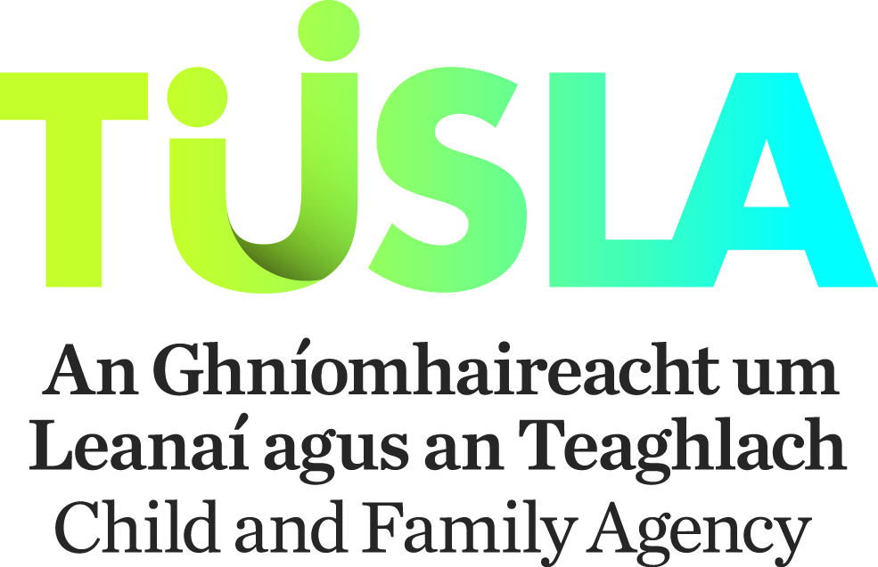

**Procedure for Drawdown of Tusla Participation Initiatives 2020**

Once an applicant has been approved for Tusla Participation Initiatives, the PPFS Senior Manager should note the following procedure to drawdown the funding.

**Projects Internally Managed**

The Tulsa PPFS Senior Manager should arrange for invoices, staff reimbursement forms, procurement cards and any other form of expenditure relating to the project to be processed in their local area office in the normal manner, but using the Tusla Participation Initiatives cost centre, Parental Participation FC192882 or CYP Participation FC193883. Please note that these cost centres have changed since 2019. Copies should be sent by email to the National Finance Officer PPFS [finbarr.howard@tusla.ie](mailto:finbarr.howard@tusla.ie) Please keep a record of your spending for review meetings with Participation and Partnership Officers.

**Projects Externally Managed (funding to be made to C&V Sector)**

If the funding is to be paid to an organisation in the Community & Voluntary sector then an SLA will have to be completed. Where the C&V organisation has a pre-existing SLA then only a new part B in respect of the Tusla Participation Initiatives project needs to be completed. If the C&V organisation does not have a pre-existing SLA then a part A and B will have to be completed. If you require support in respect of accessing the commissioning portal or completing the SLA please contact [commissioning@tusla.ie](mailto:commissioning@tusla.ie). Once the SLA has been submitted please let the appropriate person know so they can go into the Commissioning Portal and approve.

**Final Step**

Once the above is completed, the PPFS senior manager should complete and sign the attached Tusla Participation Initiatives grant payment template and send to the National Finance Officer PPFS [finbarr.howard@tusla.ie](mailto:finbarr.howard@tusla.ie) for processing.

**Please note that all projects must adhere to the Tusla financial and procurement regulations and these are available on the Tusla Hub.**

**Payment Dates**

Grant funding payments are made on a monthly basis and please note the below dates by which completed templates must be with Finance to allow payment to be made in a particular month. Please see table below.

