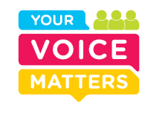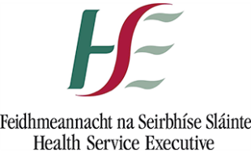

**Your Voice Matters CHO8- Midlands, Louth, Meath CAMHS**

**Information Leaflet**

Your Voice Matters focuses on what is **most important** to service users. It captures lived experiences, by asking service users to tell **their story** of a recent experience of engaging with health service. These experiences are then considered in terms of person centred, co-ordinated care and the information is used to inform service improvements.

We would like **feedback** from service users, family members and carers from the Midlands, Louth and Meath on your experience of attending the Child and Adolescent Mental Health Service .

We believe that Service user experience needs to be central to the planning and delivery of Health and Social Services. We want to hear about your experience -good and bad- so we can **improve our service.**

We invite you to complete a **paper** or **online survey**. Surveys are anonymous and confidential. Paper surveys are available at reception. You can complete the survey, place in and seal the envelope provided. Once completed the surveys are returned to the National Patient Narrative Project Office for analysis. The online surveys are available at:

<https://loncollector.sensemaker-suite.com/Collector/collector.gsp?projectID=CAMHS_MLM&language=en>

Thank you.