**We want to hear from you!**

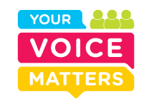

We want to hear **feedback** from **young people** and their **families** on their **experience** of attending **CAMHS**.

Ask your local Clinician for more information or visit our website on <https://loncollector.sensemaker-suite.com/Collector/collector.gsp?projectID=CAMHS_MLM&language=en>