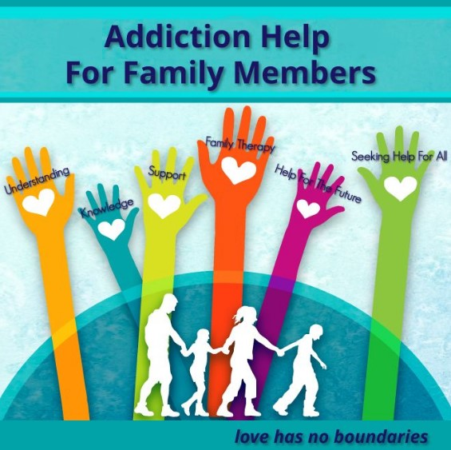

Family Educational Program for Family Members living with addiction issues

Does someone you love have alcohol or/and drug issues?

We know how difficult this is. Addiction is a complex issue that affects individuals and their families and the wider community. Families can become disconnected, our relationships suffer, and we can feel isolated and helpless.

F.A.S.N are hosting the highly recommended Family Educational Program for Family Members developed by the The Rise Foundation, which offers practical support, relevant education, coping strategies and the opportunity for people to connect through their shared experiences.

A program will run for 10weeks in the following areas:

The Hub, Lios Dubh, Armagh Rd, Dundalk and in Navan NERDATF Office, Unit 2, First floor, Kennedy Road, Navan Co Meath C15RW1 on Tuesday 18TH February from 6.30pm - 9.30pm

Please contact F.A.S.N for further details or to book your place on the following numbers:

087 904 6405 / 042 935 5251 Email: info.fasn@gmail.com

