Department of Rural and Community Development
2nd round of COVID-19 Emergency Fund

Guidelines

Please read the following guidelines carefully before completing the application form.

- Introduction

The COVID-19 Emergency Fund is funded by the Department of Rural and Community Development (the Department) and administered by the Local Community Development Committees (LCDCs) in each Local Authority area.

The 1st round of the COVID-19 Emergency Fund was launched in April, with funding of €2.5m. This is the 2nd round of the COVID-19 Emergency Fund and has funding of €1.7m.

Applications should be made to the relevant LCDC by 5pm Wednesday 27th January 2021.

Note - The Department has recommended that LCDCs ring-fence 30% of funding to provide small grants of €1,000 or less.

2. Who is eligible to apply?
In general, any not-for-profit community or voluntary group can apply.
Commercial organisations and individuals are not eligible for funding.
3. What projects are eligible for funding?
3a. What projects are eligible for funding?
It will provide grants to community groups to assist them:

- to adapt their services and operations to fit the new COVID-19 reality. Examples of measures supported could be adapting premises to allow for social distancing; offering on-line activities; providing social supports and friendly calls by phone etc.
- to become more involved in the Government's 'Keep Well' campaign. The grants are aimed at assisting participation in the campaign, in particular with the three themes: staying connected, switching off and being creative, and minding your mood.
The grants may also be provided to support groups (including those involved in the community call) with day to day running costs if needed.
3b. What is not eligible for funding?
The following expenditure is not eligible for funding:
- Any project not in keeping with the ethos of the Programme
- Legal fees
- Project management fees
- Purchase of lands or buildings
- Feasibility studies
- Private or commercial operations
- Insurance costs
- Employment costs

4. Requirements of the Programme

The following conditions apply to all projects. Depending on the nature of your project (and the group applying), there may be further requirements that must be met. The LCDC/LA will discuss this with you, if your application is successful.

Tax Requirements
- The applicant group/organisation does not have to be registered for tax purposes.
- Any applicant group/organisation that is registered for tax purposes must be tax compliant. In line with revised tax clearance procedures, which came into effect in January 2016, the Tax Clearance Access Number and Tax Reference number must be submitted for verification purposes.

Statutory Consents - Applicants must ensure that all necessary statutory permissions or consents are in place before any works commence. This includes, but is not confined to, planning permission.

Insurance - Written evidence of a valid insurance policy may be requested by the LCDC, where relevant, during the applications review process.

Acknowledgment of funding - Due to the value of some of these grants, it would not be cost-effective to require signage acknowledging the Department, Local Authority or LCDC funding contribution. Other suitable acknowledgements will suffice e.g. on a group/organisation’s website or social media platforms. Where signage is developed it should acknowledge the contribution of the Department.

Match-funding - this is not a requirement under this programme.

5. Selection Criteria

Applications will be evaluated by the LCDC to ensure eligibility and that they are in keeping with the ethos of the programme.

Projects may also be judged having regard to how they:
- increase participant or visitor or audience numbers, and improve and extend access to facilities. This may include adapting facilities to safely accommodate people or adapting services to increase virtual participation;
- invest to increase or extend the use of the facility, for example, to voluntary and community groups;
- have a positive impact on the environment, for example, a reduction in energy consumption;
- demonstrate collaboration with the local authority or other relevant bodies in the catchment area;
- support the creation of a sense of place within the community;
- address health and safety issues; and/or,
- invest in technology which will be accessed by individuals and communities

Projects may also be judged having regard to additional criteria deemed appropriate by the LCDC in each Local Authority administrative area.

The amount of funding received from other sources may also be considered.

6. Corporate Governance
6a. Monitoring:
Grantees will be required to comply with the highest standard of transparency and accountability as documented in Department of Public Expenditure and Reform Circular 13/2014 - Management of and Accountability for Grants from Exchequer Funds http://circulars.gov.ie/pdf/circular/per/2014/13.pdf
The overall principle is that there should be transparency and accountability in the management of public funds, in line with economy, efficiency and effectiveness. The circular outlines, for example, that grant recipients should not dispose of publically funded assets without prior approval.
6b. The Code of Governance for Community and Voluntary organisations

The Department is encouraging funded bodies to adopt the Governance Code, a Code of Practice for Good Governance of Community, Voluntary and Charitable Organisations, which will assist in achieving excellence in all areas of your work. The Governance Code asks organisations to agree to operate to key principles in order to run their organisation more effectively in areas such as leadership, transparency and accountability and behaving with integrity. Further information on the Code is available at www.governancecode.ie

7. Approval Procedures

In deciding the final allocations of funding to projects, the LCDC may take account of a number of factors including geographical balance and the desirability to fund a variety of different types of work and the relative disadvantage of the area where the facility is located (or will serve).

Following the decision each approved project, subject to the completion of legal formalities and other requirements, will receive an offer in principle of grant-aid. This will be subject to compliance with the relevant conditions and subject to the satisfactory acceptance by the applicant of that offer.

The right is reserved to reassign the funds offered to another approved project if all requirements are not met within a reasonable period.

The Department and/or the Local Authority reserve the right to carry out an audit of expenditure or conduct inspections from time to time.

Please Note:
Requests for assistance usually exceed the funds available and it is important therefore that the process of evaluation is rigorous. The purpose of this process is to ensure that the best projects, taking all factors into account, emerge and receive support. It is Departmental policy to ensure that every application is treated fairly and impartially.

Offers of funding may be for a lesser amount than that sought by the applicant. Applicants should be aware that the Programme may be oversubscribed. Therefore, in such circumstances, all applications fulfilling the conditions may not be successful or may be for a lesser amount.

The LCDC in evaluating proposals received may seek advice and consult with other agencies, and may disclose information on projects under consideration to those experts and agencies.

8. General

The information provided in this document is intended to give applicants an understanding of the process by which applications for funding are assessed and approved and does not purport to be a legal interpretation.

Freedom of Information Act 2014
Under the Freedom of Information Act 2014, details contained in applications and supporting documents may, on request, be released to third parties. If there is information contained in your application which is sensitive or confidential in nature, please identify it and provide an explanation as to why it should not be disclosed. If a request to release sensitive information under the legislation is received, you will be consulted before a decision is made whether or not to release the information. However, in the absence of the identification of particular information as sensitive, it could be disclosed without any consultation with you.

Site Visits
The Department, Local Authority or LCDC may carry out unannounced site visits to verify compliance with the Programme’s terms and conditions.

Further information may be requested
The LCDC reserves the right to request further information from you in order to assess your application if so required.

Usage of information
The information provided on the form will be utilised for the purposes of evaluating and administering the grant process, and to facilitate audits and any site visits. When evaluating the applications received the LCDC may seek advice and consult with other agencies, and may disclose information on projects under consideration to those experts and agencies.

Other
- Under the programme it is intended that 30% of the funding that is allocated to each Local Authority area will be ring-fenced for grants of €1,000 or less.
- Applicant groups shall self-certify that they do not have the funding to undertake the work, without the grant aid, or alternatively that with the grant they will now undertake a larger project which they otherwise would not be able to afford.
- If the funding application is for one element of a project, applicants will be required to provide documentary evidence of the availability of the balance of funding for that particular element of that project.
- There is no limit on the number of applications for different projects from any organisation. However, applicants should be aware that an equity/fairness approach will be taken by the LCDC to ensure an even distribution of funding.
- The Programme is 100% exchequer funded. Applicants are free to leverage other funding/match funding for projects (e.g. with LEADER, Tidy Towns, Town and Village Enhancement funding, etc.) although that is not a requirement of this new programme.
- It is the responsibility of the administrators of/body responsible for any other funding scheme or programme to ensure that using this Programme to co-fund a project does not contradict the rules of that other scheme/programme.
- VAT will only be paid where it is included in the application amount. No further requests for VAT payments or repayments will be accepted.

9. How to Apply

Application Form
The application form is detailed and is designed to ensure that it has the necessary information to evaluate each proposal accurately and fairly. Please ensure that you complete the application form in full and that any documentation in support of your application is submitted with your application.

Only projects that meet the criteria outlined above will be considered eligible.
PLEASE NOTE THAT INCOMPLETE APPLICATIONS OR LATE APPLICATIONS WILL NOT BE CONSIDERED.

Submission of false or misleading information at any stage is treated very seriously. Any organisation that does not comply with the terms and conditions of the Programme may be subject to inspection, have their grant withdrawn, be required to repay all or part of a grant and/or be barred from making applications for a period of time. All serious breaches of the terms and conditions of the Programme will be notified to An Garda Síochána.

ALL APPLICATIONS TO BE RETURNED TO:

communitygrants@meathcoco.ie or

Meath County Council,
Community Section,
Buvinda House,
Dublin Road,
Navan,
Co. Meath
C15 Y291

By 5pm on Wednesday 27th January 2021.

Closing date will be strictly adhered to.

Please direct your queries by email to communitygrants@meathcoco.ie quoting Covid 19 Emergency Fund.

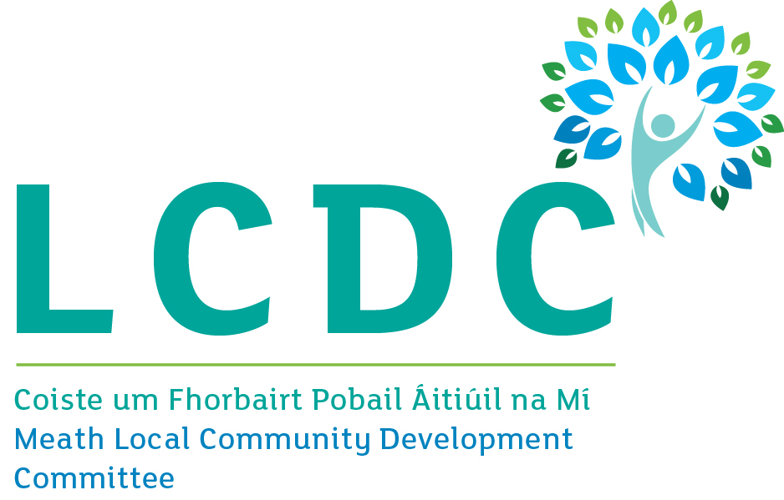

This is consistent with an action assigned to our Department under the Resilience and Recovery 2020-2021: Plan for Living with COVID-19.
This may include cross-referencing the location of the facility (or the area it serves) with the Pobal Hasse deprivation index which is available on www.pobal.ie.

