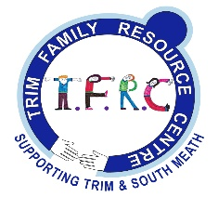
Application Form

Name: ___________________________________________________________

Address: _________________________________________________________

________________________________________________________________

Email: _____________________________________ Tel: ____________

Preferred session: Morning Evening: Either:

Family details:
Number of children: __________ Ages: __________ Res/Non-res: __________

Separation: Pending __________ Recent: ________ 2 years + __________

What do you hope to get from the programme?

How did you hear about the programme?

_________________________________________________________________

Signature: ____________________________ Date: ____________________

Please return this form to: Trim FRC, 22 Mornington Drive, Trim, Co. Meath.
Email: trimfrcfamilysw@gmail.com
Phone: 046-9438850

Data Protection
In compliance with data protection your personal details are for use by Trim FRC and will not be passed on to any other third party organisations. Your details will be held for the duration of the course unless you give permission to hold your details for any other further courses.

