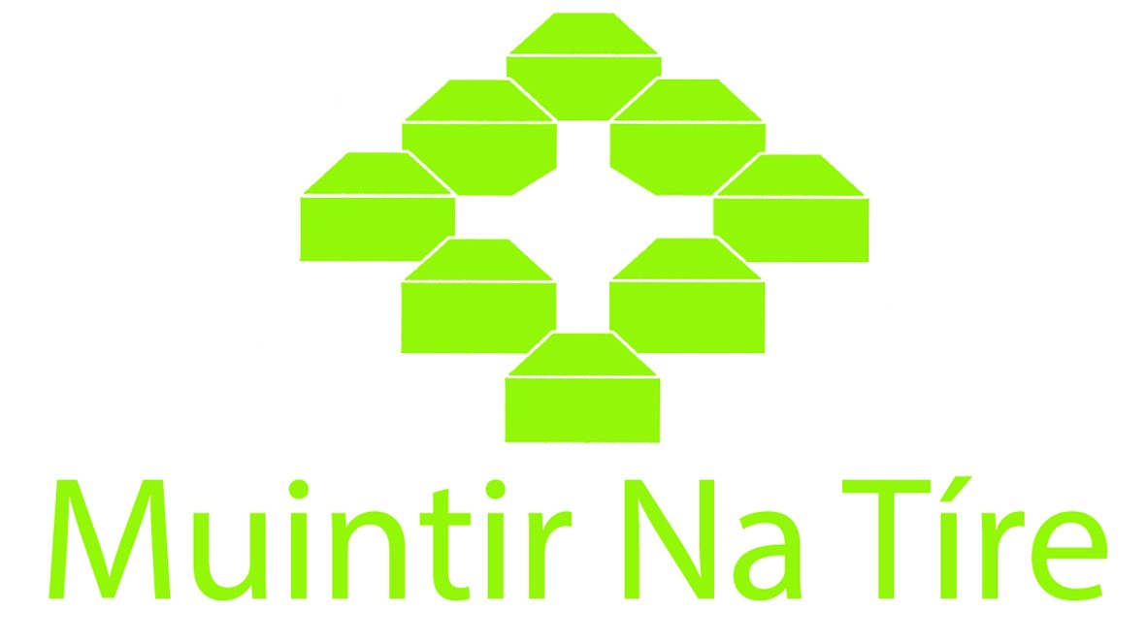
Carbon Monoxide Alarm Scheme
Householder Name ____________________________________________________________________________
Address ____________________________________________________________________________
Telephone __________________________________
Do you have smoke alarms installed? Yes No
Tick the box that best describes your circumstances:
Older person Person with Disability Unemployed
Other Please specify: __________________________________________________________________________________________________
It is your responsibility to ensure you follow the guidance contained in the manufacturer’s
instructions which are received with the carbon monoxide alarm.
Smoke alarms are provided on behalf of the Department of Rural and Community Development and are accepted and installed without liability on the part of the Department, Muintir na Tíre, and the voluntary group installing them.

I consent to my personal data, as supplied on this form, being shared with Muintir na Tíre for the purposes of administering this scheme.

Householder Signature ___________________________________________________________________

I confirm that on receipt of the Carbon Monoxide alarms, I accept full responsibility for their care and maintenance thereafter.

Householder Signature ___________________________________________________________________

Please return this form to your installer.
Group name: ____________________________________________________________________

