

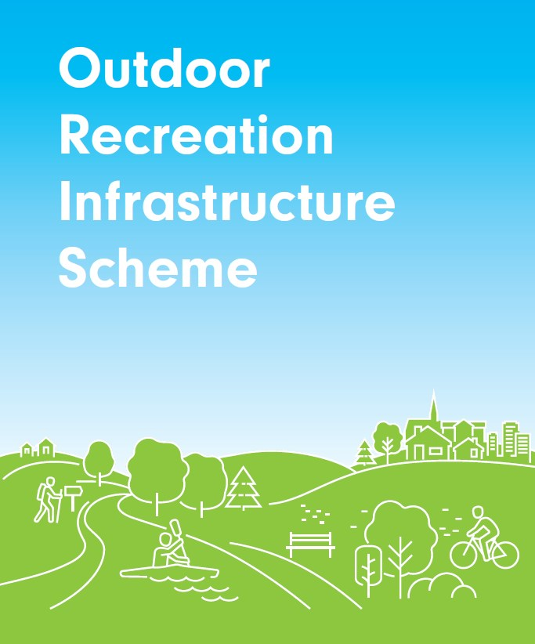

**2019 Scheme Outline**

**Outdoor Recreation Infrastructure Scheme**

**2019**

**Scheme Outline**

**Department of Rural and Community**

**Development**

Any queries and completed application forms should be addressed to ORIS@DRCD.gov.ie

Or

Rural Schemes and Policy Unit

Department of Rural and Community Development

Government Buildings

Brook Street

Ballina

Co. Mayo

F26 E8N6

# 1. Introduction

Strengthening rural economies and communities is one of the strategic objectives of the Government’s *Project Ireland 2040* strategy. The Outdoor Recreation Infrastructure Strategy (ORIS) plays an important part in that strategy for rural communities by providing funding for the development of new outdoor recreational infrastructure and for the necessary maintenance, enhancement or promotion of existing outdoor recreational infrastructure in rural areas across Ireland.

The scheme seeks to support those sporting and recreational pursuits based on use of the resources of the countryside that contribute to healthy active lifestyles and the economic and tourism potential of the area for both local communities and tourist visitors alike.

**2. Purpose of the Scheme**

The primary aim of the scheme is to provide outdoor recreational infrastructure in countryside areas across Ireland. In that regard it should be noted that proposed projects located within any of the five main city boundaries are not eligible under the scheme.

Countryside recreation applies to those sporting, recreational and holiday pursuits based on use of the resources of the countryside and which contribute to healthy active lifestyles. The term “countryside” includes land, water and air. The term “recreation” in this context applies to sporting and recreational activities, which operate in the countryside as defined above. It does not include sporting activities which take place in the countryside on confined courses or pitches specifically designed and constructed for those sports, e.g. golf, football, show jumping, etc. Successful projects will be in keeping with this definition.

The Scheme does not support sporting activities which take place in the countryside on confined courses or pitches specifically designed and constructed for those sports, e.g. golf, football, show jumping, etc.

The following will notbe supported by the scheme:

* Sports grounds, play grounds and MUGAs,
* Marked street trails within towns,
* Maintenance works on elements of trails which form a normal part of the Walks Scheme, and
* Activities which do not comply with the definition of countryside/outdoor recreation, as set out above and as defined in the National Countryside Recreation Strategy.

# 3. 2019 Scheme

The Scheme makes a call for projects of differing sizes to be put forward by interested parties and partnerships, with small and smaller to medium sized projects to be completed in 2019 and scope for the effective implementation of larger, strategic projects up to the end of October 2020. Projects supported under the scheme in 2019 should be in line with strategic plans and the Local Economic and Community Plan for the county.

A total fund of €10 million is available to successful projects approved under the 2019 scheme. The number of projects approved for funding will be limited by the amount of funding available in each measure.

Applicants are advised to take note of the relevant Assessment Criteria when completing applications.

The Department may exclude applications that do not include all relevant documentation or assurances at the time of submission. The Department may not be in a position to follow up regarding missing documentation or other queries.

Applications must be made in the format outlined below.

**4. Eligible Applicants**

* Local Authorities will be eligible applicants for all Measures.
* State Bodies will also be eligible applicants under Measure 3.
* Partnership with Local Development Companies[1] in the development of Measure 1 applications is strongly encouraged.
* It is expected that applications under all measures will reflect collaboration with a number of other bodies and communities.

Only applications submitted by eligible applicants as described in the scheme outline will be considered.

# 5. Categories of Projects

Under the 2019 scheme, applications will be accepted under three measures:

**Measure 1: Small Scale Maintenance/Promotion and Marketing**

Projects to include grant aid amounts of up to €20,000.

**Eligible Activities:** Resources to support the purpose of the scheme, including for the upkeep and maintenance of already established trails, walkways, cycleways and blueways, improved access to leisure or recreational facilities, and the promotion and marketing of such infrastructure.

**Maximum Number of Projects:** A maximum of 9 projects may be submitted per

Local Authority with an indicative prioritisation of projects and a short rationale for that prioritisation.

**Project Completion Date:** All projects must be finished and drawdown of funding completed before 25 October 2019.

# Measure 2: Medium Scale Repair/Upgrade and New Trail/Amenity Development

**Grant Amounts:** Grant amounts up to €200,000.

**Eligible Activity:** Medium sized projects that support the purpose of the scheme. Projects could include the development of new trails/walkways/cycleways/blueways, or other recreational facilities, or extensions to already established trails/walkways/cycleways/blueways. Projects can also include works for the enhancement, maintenance or promotion of such infrastructure.

**Maximum Number of Projects:** A maximum of 4 proposals may be submitted by each Local Authority.

**Project Completion Date:** All projects must be finished and drawdown of funding completed before 25 October 2019.

# Measure 3: Large Scale Repair/Upgrade and New Strategic Trail Development

**Grant amounts:** Grant amounts up to €500,000.

**Eligible Activity:** Large sized projects that support the purpose of the scheme. Projects could include the development of new larger-scale recreational infrastructure, or resources to complete larger scale/longer term developments, as well as significant repair and maintenance on already established trails/walkways/cycleways/blueways.

**Max Number of Projects:** Applicants under this measure will be confined to 1 application in this category.

**Project Completion Date:** All projects must be finished and drawdown of funding completed before 23 October 2020.

**6. Application Format**

State Agencies may apply to the scheme in the same manner as in 2018.

Local Authorities must apply to the scheme in the following manner, which differs from the one used in 2018:

* An “Application Overview” (MS Excel) document has been provided for completion and sign-off at Director of Service level indicating that the Local Authority/State Body undertakes to ensure that all required permissions, match-funding, etc. are in place or in train, and are in line with requirements outlined in this document. Proof of such is not required at the time of application but must be available to the Department or its agents on request.
* In addition to a completed Application Overview, the Local Authority/State Body is also required to submit a “Project Overview” (MS Word) document in respect of each individual project.
* The Department will provide Irish translations of Project Overviews as soon as possible, and will allow for an appropriate delay in the submission of such applications (to be notified to you); however the Local Authority is required to submit details of such applications on the Application Overview on the 31st of May.

## 7. Closing Dates

All applications under all measures must be submitted by email to ORIS@drcd.gov.ie by **5.15pm on Friday 31st May 2019.**

## 8. Assessment Criteria

Selection of projects under the Outdoor Recreation Infrastructure Scheme for 2019 will be by means of a competitive process. Final project selection will be made by the Department of Rural and Community Development on the basis of proposals submitted by the eligible applicants.

In assessing applications, a number of factors will be considered by the Department, including the information supplied in the Application Overview and the Project Overview, or the application (as appropriate); the range, mix, quality and impact of proposed projects; previous funding provided; and other relevant considerations.

Guidance on some of the questions that the Department may refer to during the assessment process are provided in the Appendix to this document. The standard of response deemed necessary to address these questions will increase in line with the amount of funding sought.

It should be noted that projects put forward under previous schemes but not approved, or subsequent phases of projects previously granted funding, may be eligible under the 2019 scheme. However, any funding approved under the Scheme in 2019 will be conditional, where appropriate, on satisfactory progress with regard to any funding approved in 2018 or previous years.

Approval will be dependent on works having not commenced prior to Department approval of the project.

## 9. Funding Conditions

Funding will be released to successful applicants in tranches based on a specified level of works being completed.

Payments will be made on an arrears basis and should only be sought when the project is completed and the Local Authority itself has incurred the expenditure.

The Department will fund up to 80% of approved project costs with the additional 20% to be provided from other sources including Local Authority funds or labour and/or other resources.

Match funding for projects undertaken must be evidenced, with a clear commitment from the organisation providing the match funding and setting out in what form the contribution is being made, i.e. cash and/or manual labour etc.

Of the 20% to be funded from other sources, a minimum of 5% of approved project costs must be funded through cash contribution by the group, the Local Authority or another body.

In-Kind Contributions: Labour or other verifiable and apportionable costs can be counted towards match funding, but should not exceed 15% of the overall cost. Labour coming from RSS / TUS or similar schemes is not allowable as an in-kind contribution.

A maximum limit of 12.5% of the overall project costs is allowable for associated administration costs, professional fees and similar, where relevant, for a proposed project. Applicants are encouraged to keep the level of such costs to a minimum and should note that the level of such costs will be a factor in the assessment of value for money as part of the application assessment process.

Works must be completed within the terms of the timelines set out in this document.

The Department may decommit funding allocated to projects under the Scheme where the works are not carried out within the time specified and where the express agreement of the Department to extend the funding arrangement has not been agreed in advance.

## 10. Payment Schedule

The payment schedule will be as follows, unless otherwise agreed:

* 50% of the total allocation will be paid when the applicant confirms in writing that 50% of the project expenditure has been incurred by the applicant body, and
* 50% payment on completion, based on expenditure actually incurred by the applicant body.

## 11. Scheme Requirements

The Scheme is funded by the Department of Rural and Community Development, and may be administered through a Local Authority and/or a State Agency, in accordance with the Measures as outlined above.

Applicants must provide a detailed description of proposed works including locations, materials to be used, breakdown of costs, personnel or resources to be utilised.

Particular emphasis should be placed on proposed works in designated areas, such as Special Areas of Conservation (SAC), Special Protection Areas (SPA), etc. bearing in mind any necessary appropriate assessments/approvals/planning permissions etc. that may need to be obtained, together with permission from the relevant agencies/landowners, are in place prior to any works commencing in these cases.

Applicants should ensure that all necessary consents are forthcoming from all relevant landowners (Private and Public) for the proposed works, and that works, where applicable, will comply with National Trails Office (NTO)/Transport Infrastructure Ireland (TII) /other relevant standards.

Applicants should ensure, where applicable, that all planning permissions, appropriate assessments etc., are in place or in train to enable works to commence as soon as possible in the event of funding being approved.

Applicants must ensure that the ongoing maintenance of the project, where appropriate, is provided for, and a record kept of same.

Applicants will be required to maintain records of all undertakings, expenditure, permissions, compliance, etc. certified in the Application Overview, and provide same to the Department or agents acting on its behalf in a timely manner, if requested to do so.

In the context of maintenance work on trails, evidence of the necessity of the relevant works must be provided on request. This evidence may be extracts from NTO Inspection reports, to support particular elements of the proposal. In the absence of a recent NTO report, photographic evidence to the nature of the required works may suffice.

Completed projects should acknowledge in their publicity material, including press releases, the support provided by the Department (all Measures) and Fáilte Ireland (where relevant) and display the Department’s logo and use the strapline: “This project received funding from the Department of Rural and Community Development and the Irish Government under the Outdoor Recreation Scheme”.

**10. Use of Your Data**

Any information submitted as part of this process may be used by the Department of Rural and Community Development for the purposes of processing your application. Further information may be sought by the Department to clarify aspects of your application.

Any personal information which you provide will be obtained and processed in compliance with Data Protection legislation.

The Department may draw on broader, more specialist expertise where required, and such information as considered necessary to complete a review of the Scheme may be shared with those experts on a non-disclosure basis.

The Department of Rural and Community Development will not otherwise release any information received as part of this application except as may be required by law, including the Freedom of Information Acts. In the event of a Freedom of Information request, the applicant will be given reasonable advance notice of any proposed disclosure.

**11. Queries**

Queries should be addressed to [ORIS@DRCD.gov.ie](mailto:ORIS@DRCD.gov.ie). **Appendix A**

|  |  |
| --- | --- |
| **Value of the project for the local area** | * Does the project outcomes have clear positive health, economic and/or tourism impacts? * Does the proposal add value to current infrastructure? * For projects exceeding €100,000 does the project demonstrate a strong economic case? * Do the outcomes of the project demonstrate a sustainable and positive impact on the local area? |
| **Strategic and collaborative nature of the project** | * Is the application collaborative in nature? * Is there evidence that the project complements or leverages other State-backed programmes or objectives? |
| **Demonstration of need and potential** | * Do the Project objectives set out a clear need for a project of this type? * Does the proposed project address the needs identified in the objectives? * Does the application mean that increased potential from an existing project will be realised? * Does the application take account of, or consider, any additional potential that might arise from completion of this project? * Where it is found that there may be additional potential to be derived from this project, does the application give consideration to how this might be developed in the future? |
| **Realistic nature of the proposal?** | * Are the timelines and costings for the project clearly set out in the application? |
| **Value for Money** | * To what extent does the project address the needs identified in the objectives? * Is there evidence that funding this project will an impact at regional or greater level? * Does the application appear to demonstrate cost effectiveness with regard to the level, range and quality of outputs and outcomes to be delivered? * Would, by funding this project, another application under this Measure of greater merit be denied funding? |

1. Local Development Companies as referenced under Section 128f(1)(d) of the Local Government Act 2001 (as amended by the Local Government Reform Act 2014) are designated eligible applicants under Measure 1 for this Scheme.