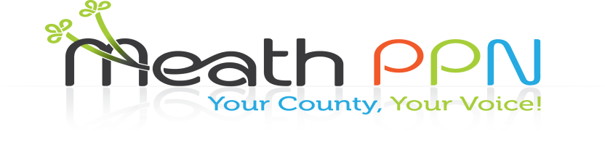

Public Participation Network (PPN) Members

What needs to happen to make things better in your community?

Come and have your say at a PPN meeting in your District on the following dates:

|  |  |  |
| --- | --- | --- |
| District | Venue | Date/Time |
| Laytown/Bettystown MD | Village Hotel, Bettystown | 7pm – 9pm Tuesday 25th September |
| Ratoath MD | Dunshaughlin Civic Offices | 7pm – 9pm Wednesday 3rd October |
| Navan MD | Buvinda House, Dublin Road, Navan | 7pm – 9pm Tuesday 9th October |
| Ashbourne | Pillo Hotel, Ashbourne | 7pm – 9pm Tuesday 16th October |
| Kells MD | Headfort Arms, Kells | 7pm – 9pm Tuesday 23rd October |
| Trim MD | Trim Castle Hotel, Trim | 7pm – 9pm Wednesday 24th October |

You will have the opportunity to:

* discuss what would make your community a better place and how this can happen
* discuss how the PPN can help your group
* share information on your group
* meet other groups in your area

If your group has any information that they would like to share, please bring it along on the night. Light refreshments will be served.

**Looking forward to seeing you**

For more detail please contact: Catherina O’Rourke on 0469097417 or email meathppn@meathcoco.ie