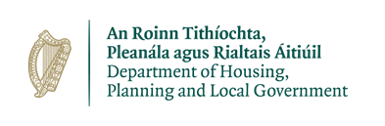

Public Participation Network Co-Ordinator

6 June 2018

RE: Local Government Funding (Baseline) Review Group

Dear Co-Ordinator

As you may be aware, the Minister for Housing, Planning and Local Government has established a Group to conduct a review of Local Government Funding (Baselines). This group, comprising representatives of the Department of Housing, Planning and Local Government and the Local Government Sector (including both the AILG and the CCMA), will recommend to the Minister a number of key indicators by which the allocation of non-programme funding to local government could be informed.

Under the current funding system for local government, every local authority has a minimum level of funding available, known as the baseline. In the context of the review of Local Property Tax (LPT), currently being undertaken by the Minister for Finance, it is timely to conduct a separate but parallel review of the methodology for allocating general purpose funding, with a view to proposing a revised allocation methodology.

To inform its work the group has decided to consult with relevant stakeholders. The purpose of the consultation process is to provide these stakeholders with an opportunity to submit ideas and suggestions in relation to local government funding. As a key stakeholder, the group would welcome the input from your organisation.

To assist your deliberations, the group has prepared a consultation document (enclosed) which provides additional background information on the Local Government Funding review, the evolution of local government funding to date and the terms of reference of the review.

You are invited to submit your response to lgfinance@housing.gov.ie by 3rd July Please note that while individual responses will not be published online they will be subject to FOI.

Yours sincerely,

_________________
Lorraine O’Donoghue
Chairperson
Local Government Funding (Baseline) Review Group

