The Annual Dunshaughlin Famine Graveyard Commemoration Ceremony - May 20th at 3pm

(behind Dunshaughlin Workhouse)

This will be followed by a talk on "Belgian Refugees in Dunshaughlin Workhouse during World War 1" by Mr. Jim Gilligan in Dunshaughlin Pastoral Centre with light refreshments.

Everyone welcome.

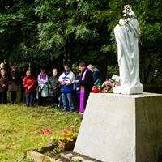

Organised by Dunshaughlin & District Historical Society