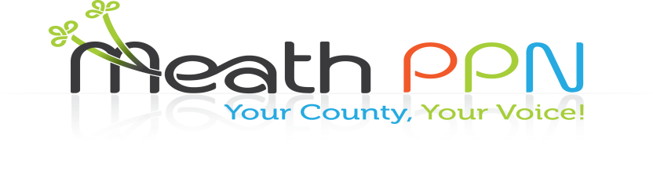

Addiction support services

Disability Groups

**Information Event on Services in Meath**

**When: Wednesday 16th May 2018, 6pm to 8.30pm**

**Where: Meath County Council Offices, Dublin Road, Navan**

Unemployment Services

Cultural Diversity

**Meath Public Participation Network Social Inclusion Pillar**

**Invite you to come along to get information on the services**

Domestic violence

**Addressing Poverty and Social Issues**

Child, Youth and older people’s services

**in Meath as part of the Plenary**

**Find out what’s happening**

**Have your views heard**

Mental Health

Training Courses

**Refreshments provided**

**Be in with a chance of winning a spot prize**

**Free parking**

Counselling Services

Family Support

Ethnic Minorities