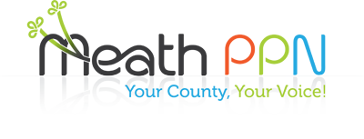 | Public Participation  Network Newsletter  Jan 2018

Update on PPN Activities for 2017 Membership: Welcome to all our new groups who joined in 2017. Membership of the PPN now stands at 530 groups. We are aiming to increase this membership over 2018.

2017 was a busy year for the PPN with an emphasis on communication with member groups, promotion of the PPN at events locally and nationally and responding to the issues raised at the Municipal District and Plenary meetings.

Committee Representation: PPN representatives are elected to sit on a number of committees which cover planning, enterprise, transport, housing, policing, environment, community and culture. Issues raised by PPN members are highlighted by representatives at meetings of these committee meetings.

In response to the issues raised by the PPN members there were a number of initiatives undertaken and supported by the Secretariat in 2017, some of which are outlined in this newsletter.

Looking forward to 2018

Training for groups in governance and data protection will be rolled out in each of the Municipal Districts. For details on this and on how you can get involved in all PPN activities go to our website: www.meathppn.ie or facebook page meath public participation network and watch out for your weekly update via email. Looking forward to seeing you at PPN events throughout 2018.

The PPN held an information day in November focusing on insurance, fundraising, governance and data protection.
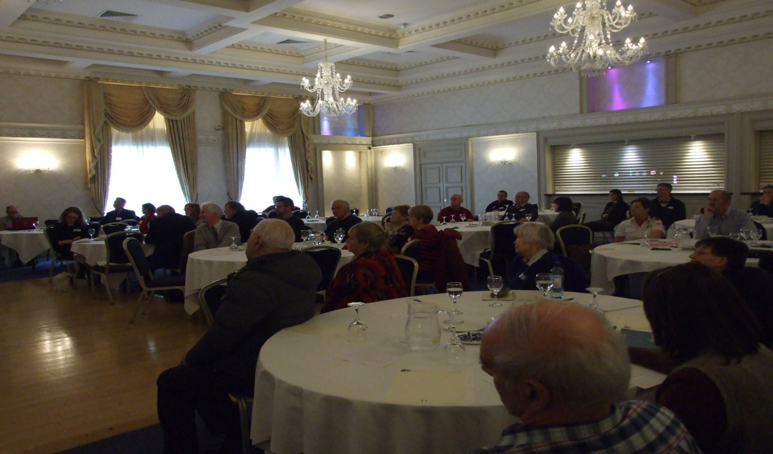
Information stands were available on the day to provide information on grants, healthy living, environmental issues, insurance, volunteering, broadband, youth services and training opportunities.
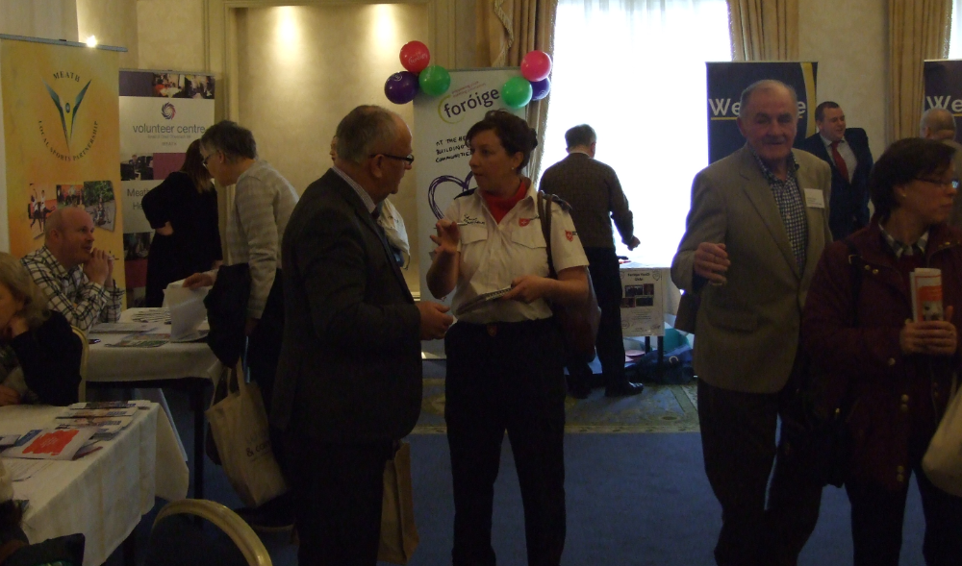

Defibrillators purchased by the PPN were presented to Active First Responder groups to be installed at 12 locations around Meath. Training was also available for the groups involved through the PPN.
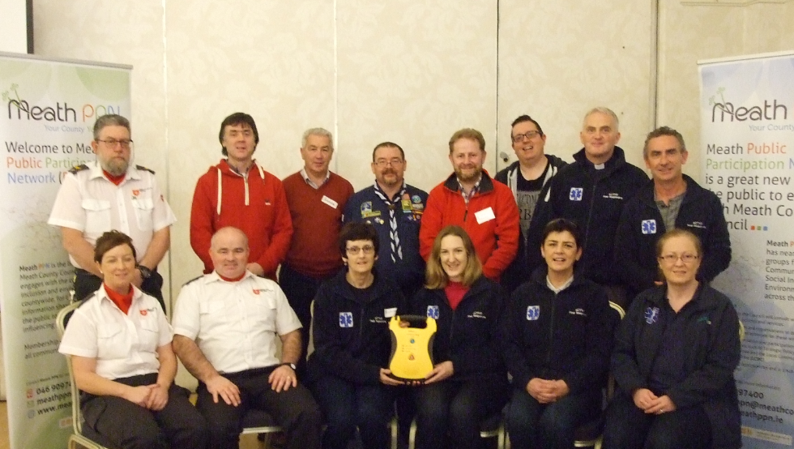
In response to the issue of waste a detailed waste survey was carried out in 2017. The findings were published through a press release and presented to the Plenary and to Meath Co. Co. Environmental Department and Environment SPC.

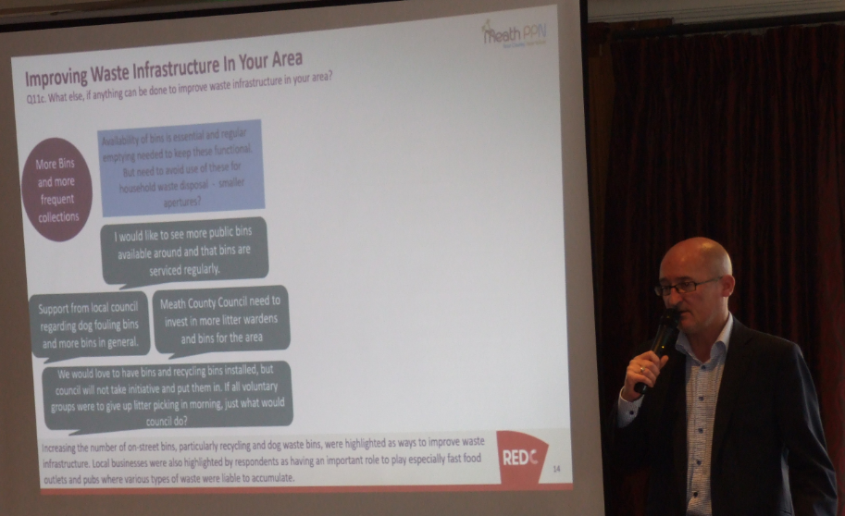

Promoting Meath PPN locally and nationally
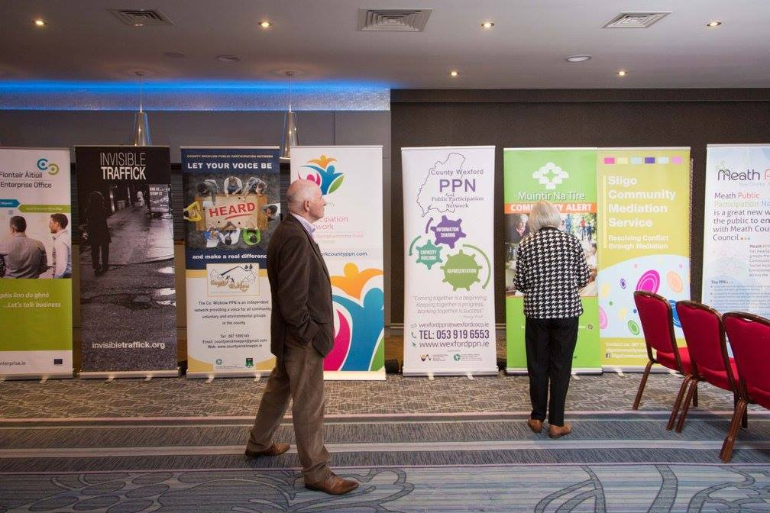
Consultations throughout Meath
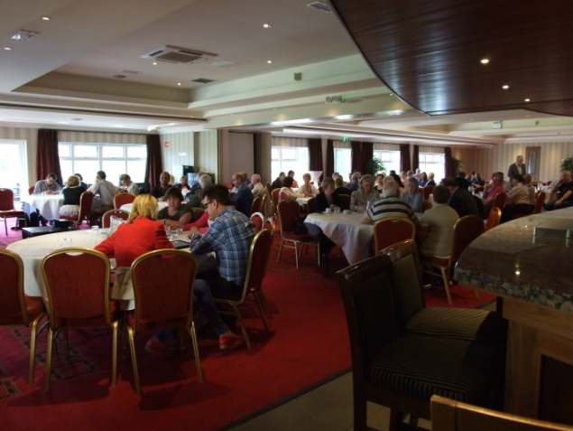
Community initiatives s promoted through Meath PPN
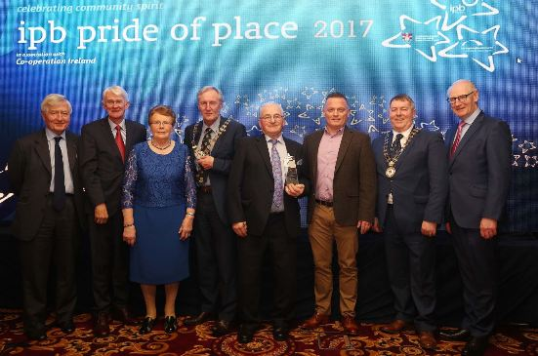
Grant schemes advertised through Meath PPN communication gave groups the opportunity to avail of funding for local projects.
Please note that the Meath County Council Community grant scheme is currently underway for 2018, details available on our website.

Libraries were presented with tables and chairs which can be used by groups for meetings in libraries
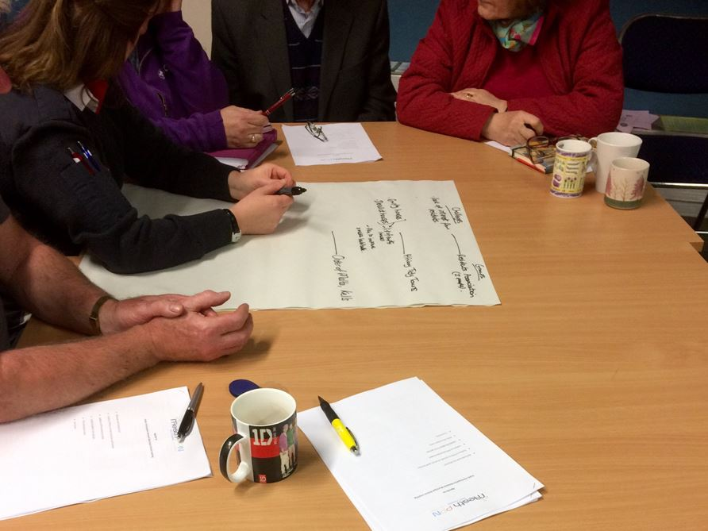
Promotion of safety initiatives throughout 2017

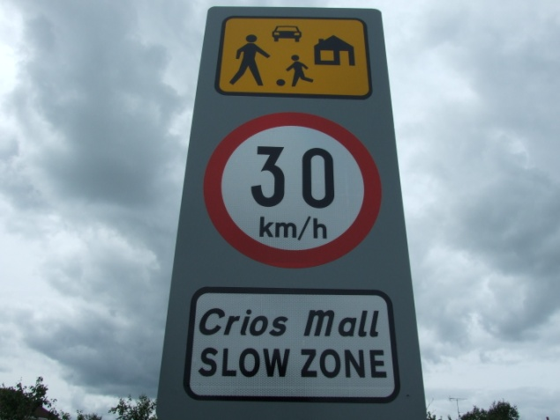
30k m speed limit in Housing Estates

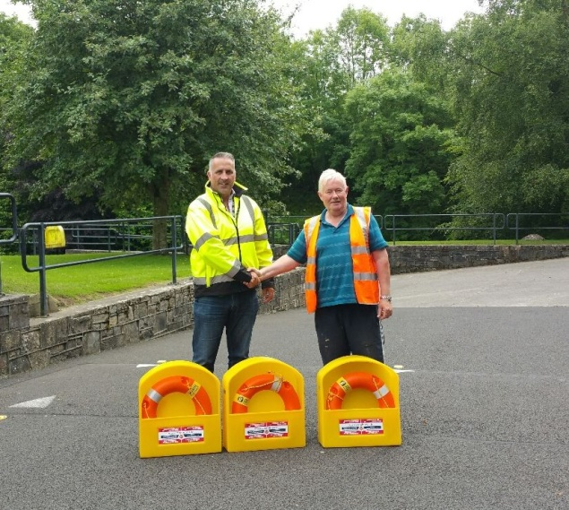
Report missing lifebuoys

