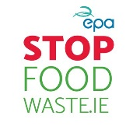
Make the Most of Your Food
The EPA’s Stop Food Waste Programme is encouraging everyone to make the most of their food, and avoid throwing out up to €700 worth of food every year. The Stop Food Waste week will run from 22 – 28 January and will highlight the issues of food waste and provide practical tips for us all to reduce it and make the most of our food.
The theme of the campaign, “Food - make the most of it”, will focus on the main foods commonly thrown away, and how to make the most of them. We will provide tips and advice on how to store and cook various food, and have developed a handy resource, the ‘A – Z of food’.
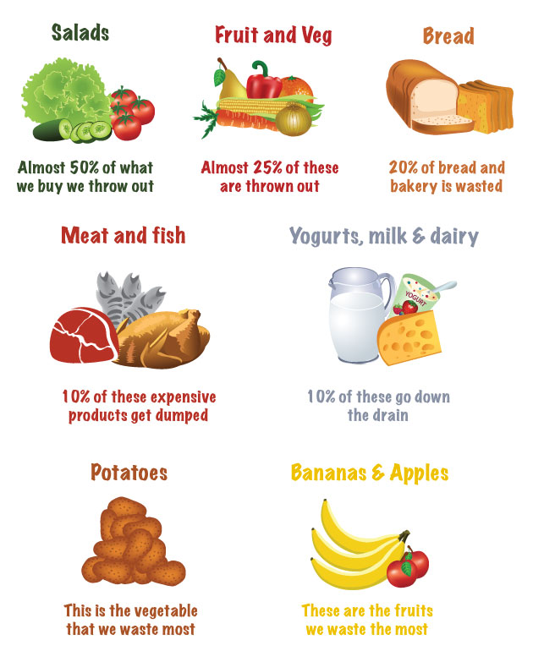
Other events throughout the week will include community screenings of the documentary ‘Just Eat It – a food waste story’, to encourage discussions on the wider issues relating food waste for communities around the country.
Odile Le Bolloch from the EPA says: “Nobody wants to waste food, but often our busy lives and changing plans mean that food bought with good intentions, doesn’t get eaten. We simply buy too much, don’t store it correctly, or we don’t eat it on time.
Making sure to correctly store and prepare our food means that when life gets in the way, our food can get another chance.”
We are all creatures of habit and when it comes to food, we often throw out the same types of food, for the same reasons, on a regular basis.
Some of the most common types of food we waste include meat and fish, dairy products, bread, and fruit and veg. The A-Z of food on the Stop Food Waste website provides ingredient specific tips to make the most of these common food items that often get thrown away. Our handy guide will provide tips and advice on how to store and cook various food types to keep them fresher for longer and not waste them.
People are invited to share their own tips on social media using the hashtag #stopfoodwaste

Follow Stop Food Waste on social media:
Twitter: @Stop_Food_Waste
Facebook: https://www.facebook.com/StopFoodWaste
And at http://meath.ie/CountyCouncil/Environment/Bins/StopFoodWaste/

- For more information about the Just Eat It documentary see http://www.foodwastemovie.com/about/

More Top Tips to help you reduce your food waste and save money
- Storage – Make sure fruit and vegetables are stored in the correct place. If you are unsure where to store your items, just copy your local shop, they try to preserve their fruit and vegetables for as long as possible.
- Examine - Use your own judgement when throwing out food. Use-by dates are for safety and should be followed, but best before dates are a guide. Labels, such as sell by and display until, are used for stock control by shops and can be ignored by householders.
- Keep all dairy products in the fridge.
- Use your freezer - If you are not going to use meat or fish, freeze it, or cook it and eat it in the following days. Also, if you decide to use just some of it, freeze the rest.
- Use stock control - Supermarkets are smart and use stock control to reduce waste. Try this at home - you'll waste less and save yourself some cash.
- Investigate – Check your fridge, freezer and cupboards before you go shopping. Poke around at the back of your shelves; it’s surprising what you may find.
- Make a list – Not only will you remember the essentials, but this will also help your costs at bay.
- Get Creative – Plan meals around the ingredients you have at home. Dig out that old cookery book for inspiration.

