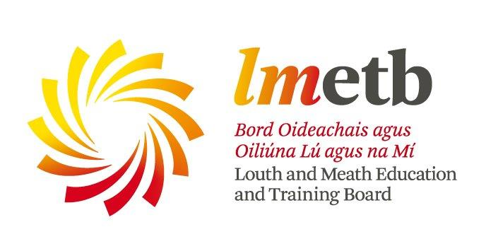


Service Grants S

Community Education Service Spring 2018 Grants

Applications are now invited from community groups and voluntary organisations for support regarding the delivery of educational programmes under LMETB’s Community Education Programme.

In line with Government guidelines for usage of funding, priority will be given to courses/programmes which aim to work with individuals and groups that experience particular and acute barriers to participation in adult learning, in particular those who wish to access learning locally, as a step to more active community involvement or certified learning. With this in mind programmes/courses should aim to address some/all of the following:

- Specifically target educational and social disadvantage
- Promote social inclusion
- Foster personal development and skills enhancement for group members
- Widen participation in learning by adults from all sectors of our community

Programmes should aim to develop the individual’s self-confidence and educational skills base in order to enable and facilitate their development and participation in the life of their community. Community-based courses are often the first step towards further options and choices for the adult learner.

The latest date for receipt of completed applications is Friday 15th December 2017. If successful, the funding must be fully used by Tuesday 1st May 2018. Funding will cover tutor payment only. The application form is downloadable from www.lmetb.ie or is available by contacting:

Jackie Breen  Community Education Facilitator (Meath)  Further Education & Training  Louth Meath Education and Training Board  Abbey Road, Navan, Co. Meath   046 9010070  jbreen@lmetb.ie | Eamonn Quinn  Community Education Facilitator (Louth)  Further Education & Training  Louth Meath Education and Training Board  Chapel Street, Dundalk, Co. Louth   042 93 64616 ext. 3216  equinn@lmetb.ie

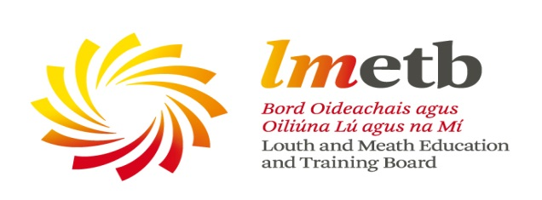

Community Education Service

GUIDELINES FOR THE COMMUNITY EDUCATION GRANTS

Definition of Community Education:

Community education is outside the formal education sector and aims to enhance learning, foster empowerment and contribute to civic society. It is delivered in local areas in response to community needs and interests. It supports social cohesion, with local community groups playing an important role in community education provision. It provides opportunities for intergenerational learning, builds self-confidence and self-esteem and for those with low skills or a negative experience of formal education it can provide a stepping stone to further learning, qualifications and rewarding work. (CEFA, “Community Education in Action”, 2013 www.cefa.ie; DES Operational Guidelines for Community Education Providers 2012)

Purpose

The purpose of the Community Education Grants Scheme is to provide funding for community education initiatives in local community settings. The LMETB grants scheme provides two options for groups to avail of this funding:

Option 1 - Financial Grant – the group can identify a subject area and source their own tutor. LMETB will provide a financial grant towards tuition costs only. If applying for Financial Grant, Tax/Charity Number is a requirement.

Or

Option 2 - Direct Tuition Hours – the group can identify a subject area and apply to LMETB. LMETB will then organise the tutor and pay them directly.

Priority

In line with Government guidelines for usage of funding, priority will be given to courses/programmes which aim to work with individuals and groups that experience barriers to participation in adult learning, in particular those who wish to access learning locally as a step to more active community involvement or certified learning. With this in mind programmes/courses should aim to address some/all of the following:

- Specifically target educational and social disadvantage
- Promote social inclusion
- Foster personal development and skills enhancement for group members
- Widen participation in learning by adults from all sectors of our community

Target Groups for Community Education Programmes

- Adults with low or no formal qualifications or low literacy levels, especially those with less than upper second level education.
- The unemployed particularly those who are long term unemployed
- One parent families
- Travellers
- Migrants/refugees/asylum seekers
- Older people
- People with a disability
- Disadvantaged women and men, particularly those living in rural isolation or RAPID areas
- The homeless
- Ex-offenders
- Substance misusers
- Underemployed/sessional and seasonal workers
- Dependents of those who are unemployed
- Low skilled people outside the labour force

Funding is available for:

Tutor fees only.
(The Community Education service may be able to assist with the provision of course materials. If your application is successful please contact us directly to discuss)

Funding is not available for:

- Community centre/group resources such as computers, cookers, tables etc.
- Rent
- Publicity and Administration costs incurred by the group
- Repeat funding of groups for the same activities; such groups need to identify progression routes for participants or clearly illustrate that new members are being engaged in such courses
- Youth Clubs/ Groups
- Sports Clubs
- For people under the age 18
Other points to note
- In assessing applications from established groups priority will be given to those showing innovation in course selection and in engaging new learners.
- For financial grant applicants:
- the funding of individuals to carry out training on behalf of a group is not acceptable (i.e. if the person applying for funding is the proposed tutor for the course)
- If a group is successful, the grant allocation will only be paid to the group once the initial documentation requested is returned (Specific Details Form and Registration/Enrolment Details of learners)
For more information please contact

Louth Eamonn Quinn Tel: 042 93 64616 ext. 3216 Email: equinn@lmetb.ie
Meath Jackie Breen Tel: 046 90 10070 Email: jbreen@lmetb.ie
Reference Code Office Use Only:

GROUP BACKGROUND INFORMATION
Name of Community/Voluntary Group | Year group was established
Tax/Charity Number (is required if applying for Financial Grant – Option 1)
Aims and Objectives of the Group/Service

Numbers of members in Group Male Female

Details of Contact Person in Group/Service
Name ___________________________________ Contact Number ____________________
Address ____________________________________________________________________
Email ______________________________________________________________________
Previous or current work of your group in the following areas:
Education/Training/Community Development

PREVIOUS AND CURRENT FUNDING INFORMATION
Has the group received funding before from LMETB? Yes No
If yes, please supply the following details
Year | Details |  | Service which provided the funding  (e.g. Community Education, Youth Office etc.,)
Has the group received core/capital funding in 2017? Yes No
If yes, please supply the following details
Details for which funding was received |  | Service/Organisation who provided the funding
Will the group receive funding from other sources towards this proposed course?
(E.g. other agencies or participants fees) Yes No
If yes, please supply the following details
Funding Provided By or Participants Fees |  | Amount and Purpose

DETAILS OF COURSE WHICH YOU ARE APPLYING FOR FUNDING
Name of Course

Will Certification be offered to participants? Yes No
If yes, please supply the following details
Course Level | Certifying Body (E.g. QQI, Red Cross etc.,)
Outline how you have identified the need for this course with your group/within your community.

State how the proposed course/project aims to address the following issues and also how it will contribute to improving the quality of life of the individual and/or the local community
- Target educational and social disadvantage
- Promote social inclusion
- Foster personal development and skills enhancement for group members
- Widen participation in learning by adults from all sectors of our community

SPECIFIC COURSE DETAILS
Proposed Venue of Course |  | Proposed Location
Number of Participants? Male Female
Target Group
(Please tick the category that applies to your group – in particular the participants who will be taking part in the programme for which you are seeking funding)
Person With a Disability |  | Traveller
Substance Misuser |  | Homeless
Ex-Offender |  | Refugee
Early School Leaver |  | Asylum Seeker
One-Parent Family |  | Migrant Worker
Community Based Women’s Grp |  | Community Arts Group
Older Person’s Group |  | Community Volunteer
Rural Men’s Group |  | Rural Women’s Group
Long Term Unemployed |  | Underemployed Sessional/Seasonal Workers
Low skilled people outside the labour force |  | Dependents of those who are unemployed
Other – Please Specify

Duration of the Course
(E.g. 2 hours per week for 5 weeks)
Proposed Day/Time
(E.g. Monday - 9.30am to 11.30am)
Proposed Start Date

How will you recruit participants for this course
Facebook Local Paper Parish Newsletter Flyers
Local School Word of Mouth Community Meeting Radio
If Other please give details ___________________________________________________
Do you agree to tell participants that the funding is from Louth Meath Education & Traning Board Yes No

COURSE COSTINGS
Option 1
Financial Grant – the group can identify a subject area and source their own tutor. LMETB will provide a financial grant towards tuition costs only.
Tuition (cost per hour)

Total Estimated Cost
Income from other sources e.g. other agencies, fee from participants etc. – Please Specify

Total Grant Sought in Spring 2018 from Community Education
Option 2
Direct Tuition Hours – the group can identify a subject area and apply to LMETB. LMETB will then organise the tutor and pay them directly.
Tuition (cost per hour)

Total Estimated Cost

Income from other sources e.g. other agencies, fee from participants etc. – Please Specify
Total Grant Sought in Spring 2018 from Community Education
Signed on behalf of the group: _____________________________________
Position in group: _____________________________________
Date: _____________________________________

Please fill in all sections of this form and return no later than Friday 15th December 2017 to:
Jackie Breen  Community Education Facilitator (Meath)  Further Education & Training  Louth Meath Education and Training Board  Abbey Road, Navan, Co. Meath   046 9010070  jbreen@lmetb.ie | Eamonn Quinn  Community Education Facilitator (Louth)  Further Education & Training  Louth Meath Education and Training Board  Chapel Street, Dundalk, Co. Louth   042 93 64616 ext. 3216  equinn@lmetb.ie
(If you require a Word version of this document please contact us by e-mail)
(Má theastaíonn cóip de Na doiciméid i nGaeilge déan teagmháil le jbreen@lmetb.ie or equinn@lmetb.ie

Checklist
Have you completed all of the categories?

Details of Community/Voluntary Group
Previous and Current Funding Details
Details of Course for which you are applying for Funding
Specific Course Details
Course Costing’s

Application Process

Successful Applications
If your application is successful, you will receive by post a Letter of Approval with Terms and Conditions Form which will need to be completed and returned prior to commencement of the course. The approval letters will be sent after the 22nd January 2018.

Unsuccessful Applications
You will receive by post an unsuccessful letter after the 22nd January 2018.
Please note if the Grant Application Form is not completed in full this will be deemed unsuccessful.

If you have any queries on your application please do not hesitate to contact us.

