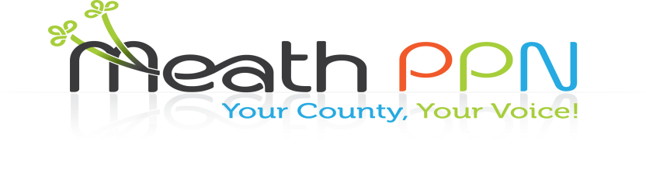

Community grants and projects

Public Participation Network Members

Insurance Cover

Save the date Saturday 18th November 10.30am to 3pm

Newgrange Hotel, Navan

You are invited by the Community Pillar of Meath PPN to come along and find out:

How your group can reduce insurance premiums

Fundraising

Environmental grants and projects

What insurance cover your group needs

Grants schemes for your group

Making successful grant applications

Fundraising tips for your group

Volunteering

Governance

What you need to know about governance

Community Environmental projects

Drop in and get advice at the information stands

Participate in the information sessions

Training Courses

Lunch and spot prizes

Light lunch provided

Be in with a chance of winning a spot prize

Free Parking at County Hall, Railway Street