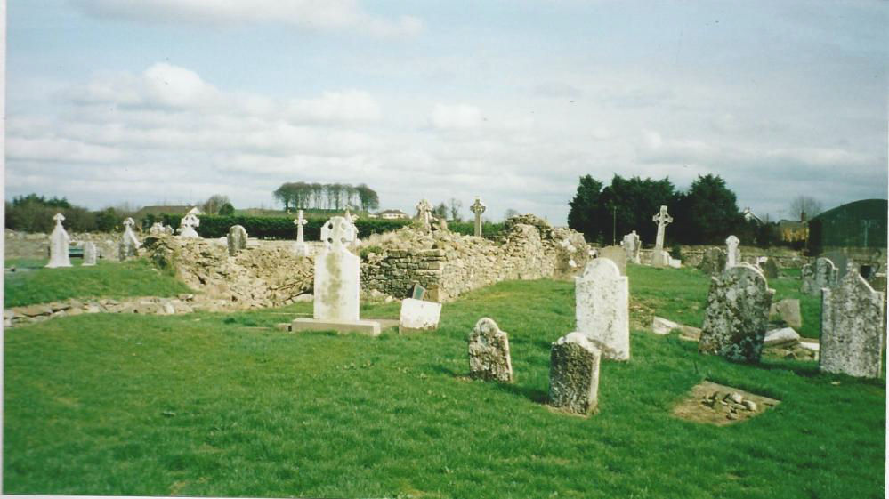

**Survey of Kilberry Graveyard**

**VOLUNTEERS NEEDED!!**Help us to photograph and record the headstones in Kilberry graveyard. Drop in over the two days. NO EXPERIENCE needed, full training will be given.   
Contact Ciara on 085 1673463 or [kilberryamenitygroup@gmail.com](mailto:kilberryamenitygroup@gmail.com)

**Friday 15th & Saturday 16th September 10am – 4pm**

