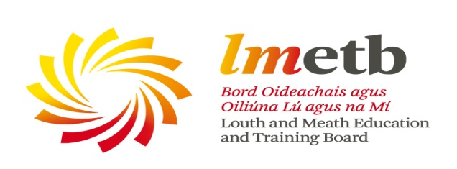

Community Education Service Grants Summer/Autumn 2017

Applications are now invited from community groups and voluntary organisations for support regarding the delivery of educational programmes under LMETB’s Community Education Programme.

In line with Government guidelines for usage of funding, priority will be given to courses/programmes which aim to work with individuals and groups that experience particular and acute barriers to participation in adult learning, in particular those who wish to access learning locally, as a step to more active community involvement or certified learning. With this in mind programmes/courses should aim to address some/all of the following:

- Specifically target educational and social disadvantage
- Promote social inclusion
- Foster personal development and skills enhancement for group members
- Widen participation in learning by adults from all sectors of our community

Programmes should aim to develop the individual’s self-confidence and educational skills base in order to enable and facilitate their development and participation in the life of their community. Community-based courses are often the first step towards further options and choices for the adult learner.

The latest date for receipt of completed applications is Friday 28th July 2017. If successful, the funding must be fully used by Friday 15th December 2017. Funding will cover tutor payment only. The application form is downloadable from www.lmetb.ie or is available by contacting:

Imelda Prunty
Adult Education Officer
Louth Meath Education and Training Board
Abbey Road
Navan
Co. Meath
 046 9012153  iprunty@lmetb.ie

