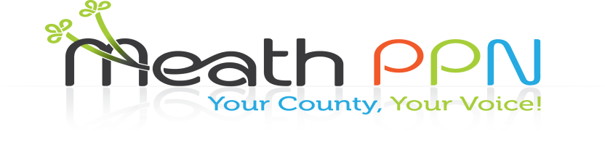

**For the attention of all groups registered with the Public Participation Network in Meath**

**You are warmly invited to a meeting of all PPN groups in Meath**

**On Wednesday 24th May 2017**

**In The Knightsbrook Hotel, Trim, Co. Meath**

**Registration from 7pm, start time 7.30**

**Catch up with other groups from around Meath**

**Find out how your group can apply for a defibrillator**

**Get an update on all PPN activities including the waste/litter survey**

**Find out how you can become more involved and have your say**

**Tell us what is important to your group**

**You will be entered into a draw on the night and could win a great prize**

**Looking forward to seeing you**

For more information please contact:

**Catherina O’Rourke on the details below:**

**By phone: 046 9097534**

**By Post: Catherina O’Rourke, PPN Resource Officer, Community Department, Meath County Council, Buvinda House, Dublin Road, Navan Co. Meath C15 Y291.**

**By email: catherina.orourke@meathcoco.ie**