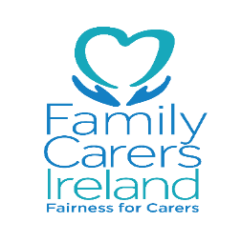
Digital Skills for Citizens Initiative: Free Training
Family Carers Ireland was among fifteen organisations awarded funding from the Department of Communications, Climate Action and Environment under their Digital Skills for Citizens Programme. The Department describes the purpose of the scheme: “The internet is a wonderful resource and it's for everybody. However, almost one in six Irish adults has never used the internet. The Department's 'Getting Citizens Online Programme' is, in line with the National Digital Strategy, focused on encouraging and empowering citizens to participate fully in Ireland's digital economy and society. The Programme includes a grant scheme to fund digital skills training for citizens who have never used the internet with a view to removing a key barrier to digital adoption.”
The Programme aims to target what it calls ‘non-liners’, i.e. those who are not currently or have never been online, offering skills to give them confidence in using the internet. Courses will be offered by Family Carers Ireland (FCI) over the coming year in locations around the country. We are currently recruiting qualified tutors and finalising locations and other details of the training, and will advertise locations soon. Ideally there will be 10 Participants in a class and these will be offered the following in 5 two hour sessions:
- Productive Use of Digital Skills (min 6 hours)
Introduction to the Internet /Internet safety & Security
Email / Search engines & websites
Online government services
Conducting everyday transactions
Online voice & video calls / use of Apps
- Lifestyle Choices (4 hours – can select two of these topics)
Specific government online services
Social media / video, TV & Radio
Shopping Online
Instructional videos on You Tube
Online Banking, including the process and security safeguards
Digital photography
Revision of one or more topics under Programme A.
If you know anyone who would benefit from these courses, do let them know about the scheme, or if you feel that you would yourself like to avail of it, don’t hesitate to contact us.
To register your own, a friend or a relative’s interest, you can contact Sheena or Eithne in our Ennis office on 065 6866515/086 4121869, or you can drop in to your local FCI centre to enquire about the courses.
This project is funded by the Department of Communications, Climate Action & Environment.

