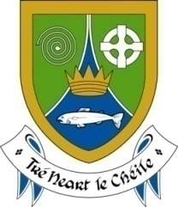
Meath County Council
Community Heritage Grants Scheme 2017
Please read guidelines before completion. Additional information may be included on separate sheets:
Closing date Monday 24th April 2017 at 5pm

Part A – Applicant
Name of Group/Organisation

Contact Person

Address for correspondence

Phone No

Email

Website

Social Media (Facebook/Twitter)
Insurance company and policy ref. no.
Is your group/organisation affiliated to Meath Public Participation Network | Yes No  (If not, please request affiliation form from community@meathcoco.ie)

Part B – Applicant Details
When was your group formed?

What are the aims and objectives of your group?

Do you want to join Heritage Office mailing list? (Please tick X in the box) | Yes No

Part C – Project

Title of the project

Project Description
Please give a description of the proposed project
(Please tell us what you want to do in max 500 words and please include photographs (if relevant)

Location of the project
(Please include location map at appropriate scale)

Which category best describes your project  (Please tick X in the box) | Heritage Research  Heritage Management  Heritage Education, Community  and Outreach
Please give a description of the proposed project
(Please tell us what you want to do in max 500 words and please include photographs (if relevant)

What are the aims of your project? What do you intend to achieve

Who will be involved in the project?

What will be the public benefit of your project for the community in your area?

When will the project start and end?

How many people will the project reach? How do you intend to inform and engage the public about the project?

Heritage Week 2017  Applicants should show us that you will hold an event during Heritage Week, 19-27 August 2017. The theme for the week this year is Nature and People. However, this does not exclude events that are not focused on the theme. For example, if your project is focused on a local archaeological site, please hold an event about your project and the site. You must register your event on www.heritageweek.ie – (registration opens May 2nd) | Please give us details of the events you propose to have during Heritage Week 2017?
Part D – Ownership of any land, building, object on which you will be working

Project site address (where relevant)

Does your organisation rent the site? |  | Yes No
Does your organisation own the site? |  | Yes No
If No, give details of the owner of the site

Has the owner of the land, building, collection owner etc., given permission for the project?  If yes include confirmation of same |  | Yes No

Part E – Consents (if applicable)

Does your project involve work:
….within an cSAC, SPA, NHA or pNHA? | Yes No
….to a protected structure? Or within an Architectural Conservation Area (ACA) (please refer to Meath County Development Plan on www.meath.ie if you are unsure) | Yes No
….to a recorded monument? (please refer to www.archaeology.ie if you are unsure) | Yes No
Does your project require any of the following?

Planning Permission | Yes No Making  application
If yes, please state Planning Reference No: ______________________________

Planning permission or declaration for works to protected structures | Yes No Making  application
Fire Safety Certificate | Yes No Making  application
Road Closure Order | Yes No Making  application
Event Licence (more than 5,000 persons) | Yes No Making  application
Consent from the National Monuments Service or National Museum of Ireland (as appropriate) for work on archaeological sites, objects or wrecks | Yes No Making  application
A licence for work on a foreshore for which an application is required from the Foreshore Unit of the Department of Housing, Planning, Community and Local Government | Yes No Making  application
Written permission for access to private property, museum collections, archives or lands | Yes No
Consent from National Parks and Wildlife Service for work on sites designated for nature conservation (i.e. Special Areas of Conservation, Special Protection Areas and Natural Heritage Areas) | Yes No Making  application
Letters of support from organisations or individuals whose involvement of help is vital for your project’s success | Yes No
Other approvals, permissions, licenses or consents | Yes No
Please Note: If the project involves activities in and around a National Monument, a site on the Record of Monuments and Places, a Special Protection Area (SPA), a candidate Special Conservation Areas (SAC), a Natural Heritage Areas (NHA) or if it requires alteration or export of an archaeological or heritage object, legal permission to carry out such works must be granted by the relevant agencies. It is the responsibility of the applicant to be aware of the current heritage legislation and to obtain such consents. Meath County Council cannot accept responsibility for actions arising from failure to provide correct information. Details on the locations of heritage sites and relevant data can be obtained from the Meath County Council website www.meath.ie and the Department of Arts, Heritage, Regional, Rural and Gaeltacht Affairs websites www.archaeology.ie and www.npws.ie .

Part F – Criteria

Each project must benefit an element of heritage as listed in the Heritage Act, 1995 or local history/genealogy/folklore/folklife. Please indicate which element your project benefits. (Please tick)

Monument | Archaeological Object
Heritage object | Flora, Fauna, Wildlife habitats
Landscape | Architectural Heritage
Inland waterways | Geology
Seascapes | Wrecks
Heritage gardens and parks | Local History/Genealogy/Folklore/Folklife

Part G – Budget for the project

 | Amount €:
How much will the total project cost?

How much are you seeking from the Community Heritage Grants Scheme?

Other sources of funding for this project:
Own Resources

Fundraising

Borrowing

Sponsorship/Donations/Fees

Other grant schemes (please state which one)
Other
Please Note:
- No double funding for projects from Meath County Council is allowed

Please provide a breakdown of proposed costs associated with the project
Item | Cost
Total Project Cost (€)
- Please include a quotation(s) with your application
- Please note receipts are required at the end of project to draw down the grant

Part H – Competent Advice

Applicants must identify a competent person with knowledge, skills and expertise in a relevant field of heritage who will supervise the project. Give details of their qualifications

Name

Address

Qualifications

Disclaimer
Meath County Council shall not be liable in respect of any loss, damage or costs of any nature arising directly or indirectly from this application or the subject matter of the application. Meath County Council, its servants or agents shall not at any time in any circumstances be held responsible or liable in relation to any matter whatsoever arising in connection with the development, planning, construction, operation, management and/or administration of individual projects.

I have read and understood the information and criteria applicable to this grant scheme and by signing below, I declare that:
- I am authorised to sign this application on behalf of the Applicant
- the information in this application and all information given in any documentation submitted in support of this application is truthful and accurate
- I understand that, if any of the information is deliberately or unintentionally misleading, the Council will reject the application

Signed on behalf of the applicant organisation:

Name (CAPITALS)

Signature

Position in group

Date

Late applications will not be considered. Please return completed application form to Heritage Office, Meath County Council, Buvinda House, Dublin Road, Navan, Co. Meath C15 Y291 or by email heritage@meathcoco.ie on or before Monday April 24th 2017 at 5pm.
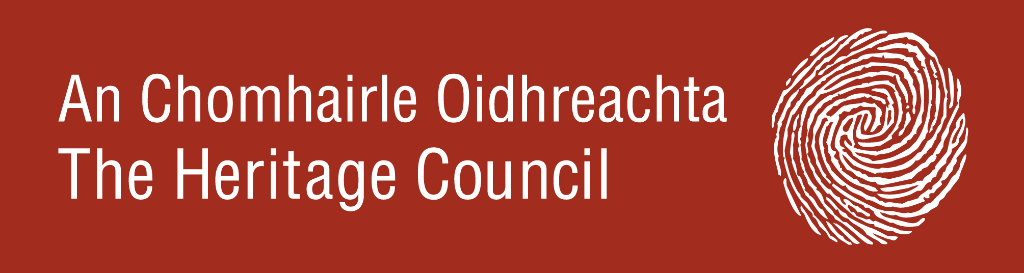

Please note the maximum amount of grant funding towards the cost of a project is 75% of the overall project costs generally up to a maximum of €1,000

