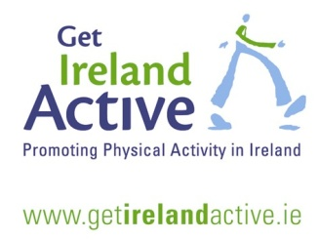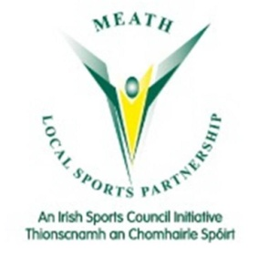**Operation Motivation Meath**

Operation Motivation is a series of county wide physical activity programmes designed to get you up and active for the New Year! Opportunities to kick start your active year are detailed within:

Following on from National Walk Day, a number of areas are planning **weekly walks** in their local areas to coincide with the **8 Week Operation Transformation programme**. See below for details:

|  |  |  |  |  |
| --- | --- | --- | --- | --- |
| **Athboy** | Alma McClorey | 087-6450811 | Mon & Wed @ 7pm | Waxies Corner |
| **Ballivor** | Paul Perry | 089-4303768 | Thurs 12th Jan @7.30pm | Ballivor GAA Grounds (Walking Track) |
| **Bohermeen** | Stephen Ball | 086-0792580 | Sat 14th Jan @11am | Bohermeen Community Centre |
| **Carlanstown** | Kay Brogan | 087-2350317 | Wed 11th Jan @7.30pm | Centra, Carlanstown |
| **Carnaross** | Noeleen Farrelly | 086-3260857 | Wed 11th Jan @9.15am | Carnaross Hall |
| **Castletown** | Nichola Smith | 086-8617289 | Sat 7th Jan @ 10am | Community Centre (Pitch & Putt Club) |
| **Cormeen** | Aine Reilly | 086-7732649 | Jan: Mon 9th 10am &Thur 12th @11am | Cormeen Sports Complex |
| **Donore** | Malena McLoone | 087-6890892 | Mon 9th Jan @7pm | Donore National School |
| **Kells** | Ann Smith | 087-9781474 | Wed 11th Jan @8pm | Gael Colmcille Centre |
| **Kiltale** | Jackie Jackson | 087-6468107 | Wed 4th Jan @7.15pm | Kiltale GAA |
| **Navan** | Michael Murray | 086-0757434 | Wed 11th Jan @7pm | Old Town Hall |
| **Tara** | Kay Carroll | 086-3684959 | Sun 15th Jan @9am | Hill of Tara car park |
| **Trim** | Patricia Edmonds | 087-6998799 | Jan: Mon 16th @8pm & Fri 20th @10am | Trim Castle (Opp. Garda Station) |

**Are you MALE, aged 30 plus?**

**Would you like to be fitter?**

**Healthier? And have a bit of craic in the process?**



**Men on the Move programme is a 6 week sports based programme for MEN ONLY**

**Men on the Move will start in Navan on Thursday 12th January at 7.30pm in Claremont Stadium.**

**Please note – this programme is open to all men regardless of fitness level.** Contact Ruairi on 046-9067337 or email [rmurphy@meathcoco.ie](mailto:rmurphy@meathcoco.ie) for further information.

**Learn 2 Run to 5k**

**Struggling with your New Year’s “get fit” resolution? Why not train in a group?**

Learn 2 Run to 5k is ideal for those who are walkers and wish to become joggers or joggers who wish to become runners – open to men & women. An experienced running coach will be in attendance each night to provide advice and support. No running ability required! Venues for training include:

|  |  |  |
| --- | --- | --- |
| **Area** | **Details** | **Contact** |
| **Bohermeen** | Beginners running group starts Mon 9th Jan @7pm; Advanced running group starts Sat 7th Jan @9am; both at Bohermeen Community Centre. | Stephen Ball 086 0792580 |
| **Carnaross** | Walk or Run every Sun evening @6.30pm Carnaross football club. | Noeleen 086 3260857 or Ann 086 3603291 |
| **Donore** | Couch to 5k starting Mon 9th January @7pm – continuing every Mon & Wed at Donore NS | Ken Brien 086 8635470 |
| **Dunboyne** | Couch to 5k commences on 5th Jan - every Tues & Thurs @9pm Dunboyne AC track, Rooske Rd. | Geraldine Fagan 087 2218540 |
| **Dunshaughlin** | Early Feb – check out Dunshauglin AC facebook | Paddy Mangan 087 2597731 |
| **Enfield** | Enfield- Fit 4 Life/Meet n Train Mon & Wed @ 7pm; Sat @ 8am | Geraldine Cusack 087 2376267 |
| **Kells** | Mon 16th @7.30pm – meet @ HSE offices, Kells Business Park. | David, Meath LSP @ 046 9067337 |
| **Navan** | Starting 16th Jan at 7pm Claremont Stadium, Navan. | David, Meath LSP @ 046 9067337 |

**Target: Royal County 5km/10km on Bank Holiday Monday May 1st 2017 in Kells**

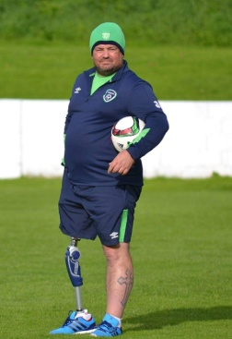**Join Operation Transformation leader, Chris McElligott for the FIT-ABILITY circuit training classes commencing on 19th Jan @ 6.30pm in Dunshaughlin Community Centre.**

**This FREE 6 week programme is open to adults with physical disabilities**

**Contact Elaine @ 046 9067337 for further information.**



**Parkrun - Weekly Free 5km Timed Runs www.parkrun.ie**

**Parkrun Navan** - every Saturday at 9:30am in Blackwater Park, Windtown Road, Navan; **Parkrun Oldbridge** - every Saturday at 9:30am meet at Battle of the Boyne Visitor Centre, Oldbridge, Drogheda, Co. Meath

For details of all other activity programmes and events please see [www.meathsports.ie](http://www.meathsports.ie) , call 046-9067337 or email [mlsp@meathcoco.ie](mailto:mlsp@meathcoco.ie)