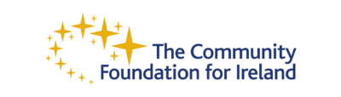

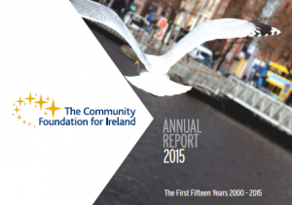 | 2015 Annual Report Launch  In line with The Community Foundation for Ireland’s commitment to attaining the highest standards of transparency and governance, the report lists all grants awarded by CFI and its donors in 2015  Read more

The Community Foundation for Ireland one of six charities to receive €1m via sale of Vodafone shares
Irish shareholders in Vodafone and Verizon have contributed €1 million to local charities recently through Computershare.

Read more

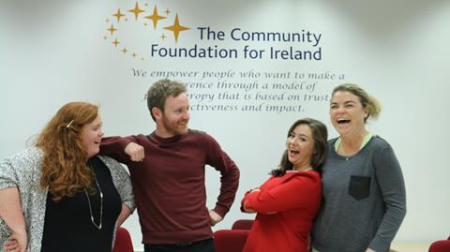 | The Youth Participation Panel (#YPP) features on YouthGiving.org and continues grant making in 2016  The Youth Participation Panel (#YPP), The Foundation’s first youth grant making panel is featured in the newly released youth giving database featured on www.youthgiving.org.  Read more

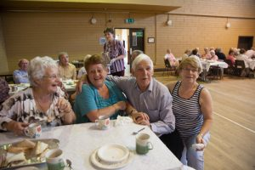 | The Older Persons' Fund Round 4 will open on August 9th  The Older Persons’ Fund Round 4 will open for applications on the August 9th and close on the September 23rd 2016. This year we have two categories in which organisations can apply for funding under.  Read more

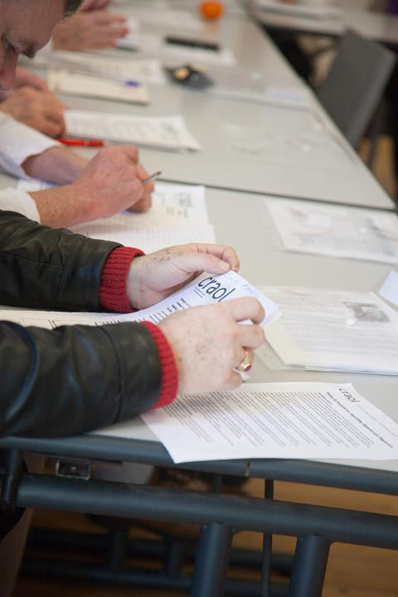 | Grant Spotlight-CRAOL has trained 138 older people to become radio broadcasters  In 2015 The Community Foundation for Ireland awarded CRAOL an Impact Grant of €185,000, to be spent over two years, to give greater “voice” to older people. With the funding, CRAOL is providing innovative programme-making training for older persons in community radio stations across Ireland. The objective is to enable older people to be able to advocate on their own behalf through programmes that are made about issues facing them, involving older people not just as contributors but as programme makers.  Read more

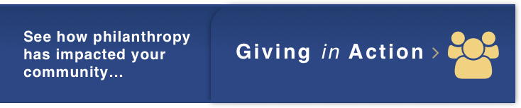
​ | We empower people who want to make a difference through a model of philanthropy that is based on trust, effectiveness and impact. |  | ​

The Community Foundation for Ireland, 32 Lower O' Connell Street Dublin 1, D01 K0V2
Tel: 353 (0)1 8747354 | Email: info@foundation.ie
Company Registration No: 338427 | Charity No: CHY 13967 | Charities Regulator Number 20044886

Unsubscribe

