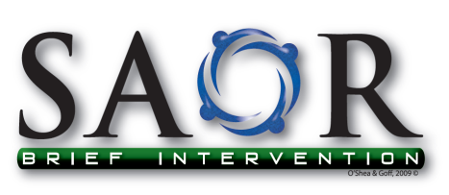
National Programme for Screening and Brief Interventions (SBI) for Problem Alcohol &Substance Use: One Day Course
Aim
This course aims to prepare professionals to implement Screening and Brief Interventions (SBI) for problem alcohol and substance use.

Learning Outcomes
On completion of this course, participants should be able to:
- Critically discuss problem alcohol and substance use as it impacts on their current work or area of practice
- Demonstrate an enhanced knowledge and awareness of contemporary models of screening and brief intervention for problem alcohol and substance use
- Identify problem alcohol and substance users who present to health and social care settings
- Utilise the SAOR model of Screening & Brief Intervention (SBI) in practice based scenarios
- Discuss the application of the SAOR model of screening and brief intervention for problem alcohol and substance use into their practice

Course Content
The key course content which emerges from the course learning outcomes is outlined below:
- Evidence for the effectiveness of SBI.
- Alcohol and substance related presentations to health and social care settings.
- Contemporary models of SBI for problem alcohol and substance use.
- Overview of the SAOR model of intervention for problem alcohol and substance use.
- Establishing a supportive working relationship with service users.
- Asking about alcohol and substance use and screening for alcohol and substance related problems.
- Delivering a structured brief intervention based upon the SAOR model.
- Developing appropriate care pathways for service users and arranging appropriate follow up.
- Accessing useful links and reference materials for further reading and research.

Accreditation:
- Category 1 Bord Altranais Approval, 6 CEU’s for registered Nurses and Midwives
- Training accredited by the Irish Association of Social Workers

Sessions will be held on the dates listed below. Sessions will start at 9.15am and run until 4pm
- 20th May 2016: Navan (The Unity Centre, Windtown, Navan)

How to Apply
- Please complete the attached form an return to info@nedrugtaskforce.ie
- Places are limited and you will be contacted by return email to confirm a place is available.
- Course material will be emailed to participants in advance of training.
- Closing date for receipt of completed application forms:
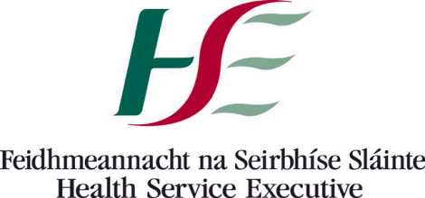
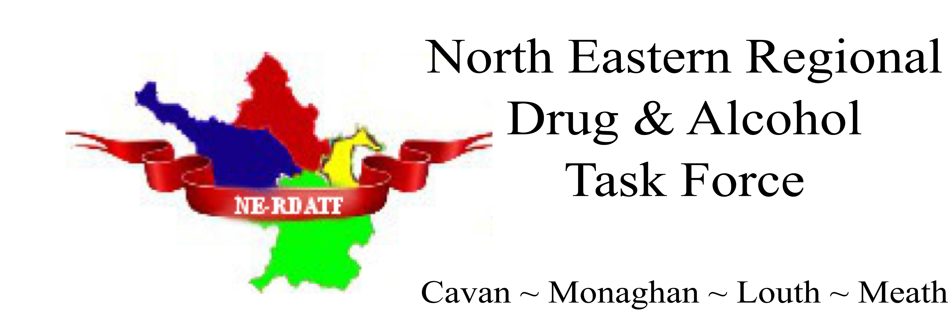
- 16th May 2016 for the Navan session
Registration Form for SAOR Training

Please email to: info@nedrugtaskforce.ie / 046 924 8630

First name | Surname | Job Title | Name of Organisation/community group | Address | Phone | Email | Training Date

Places are limited to a maximum of 20 per training day

