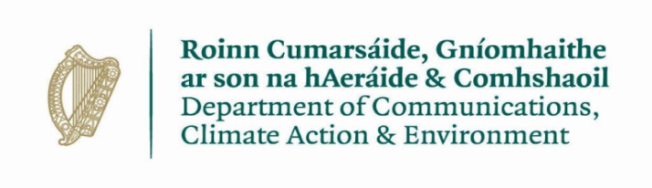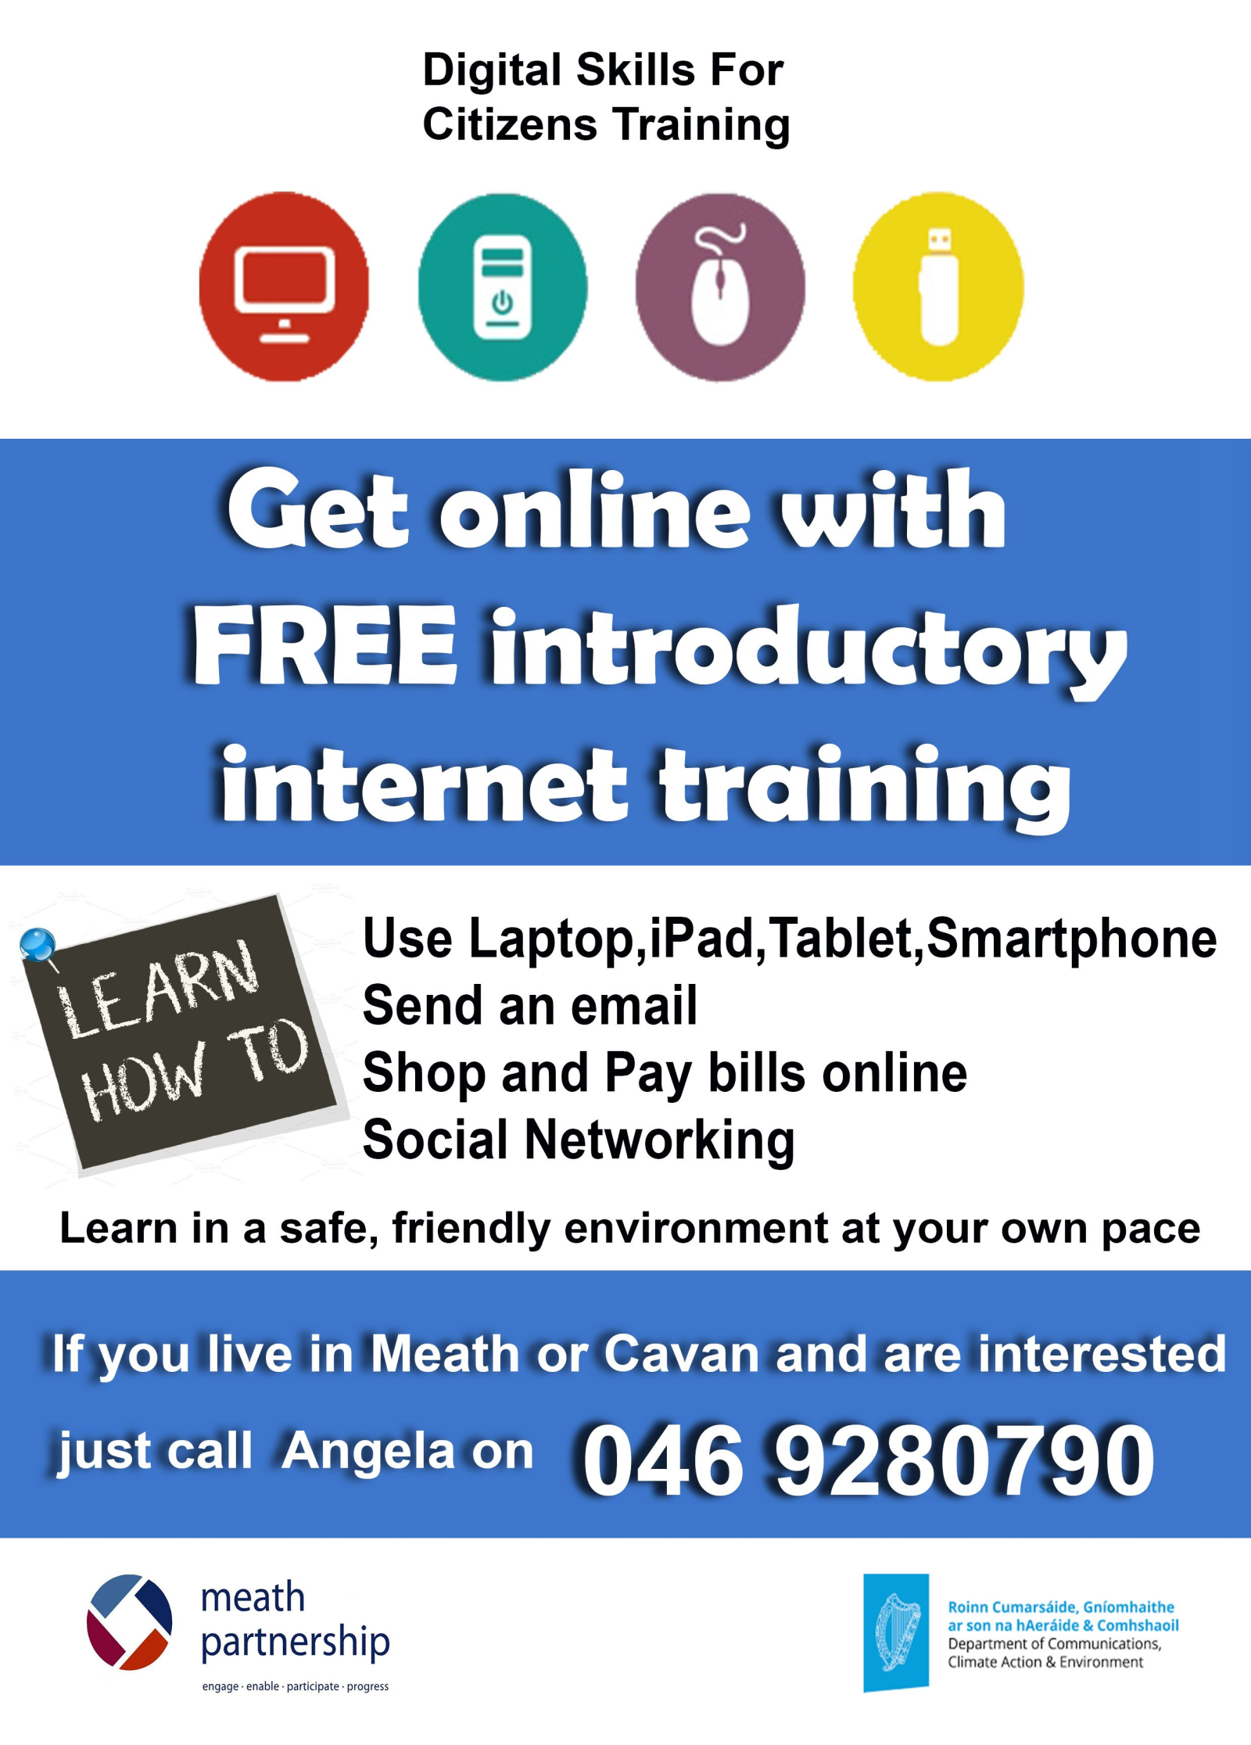

**Free Five Week Basic iPhone, iPad, Tablet and Smartphone class commencing in Cortown GFC Clubhouse on Monday 3rd September from 10– 12 Noon. Please call Angela on 046 9280790 to book a place.**

**.**