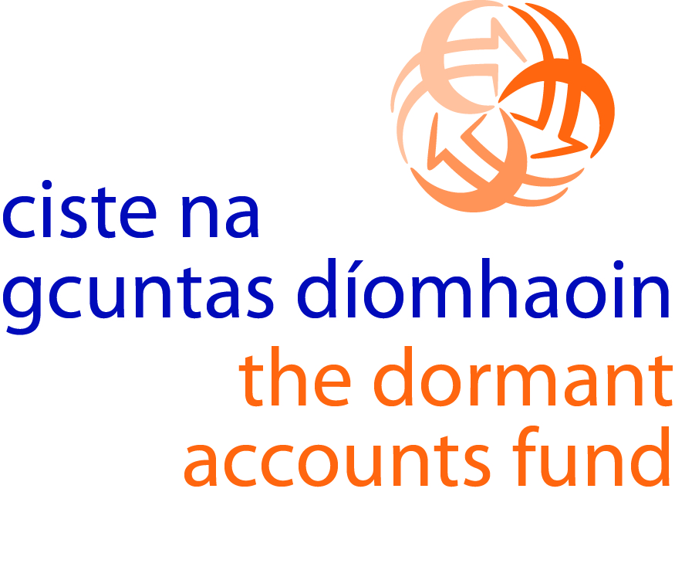
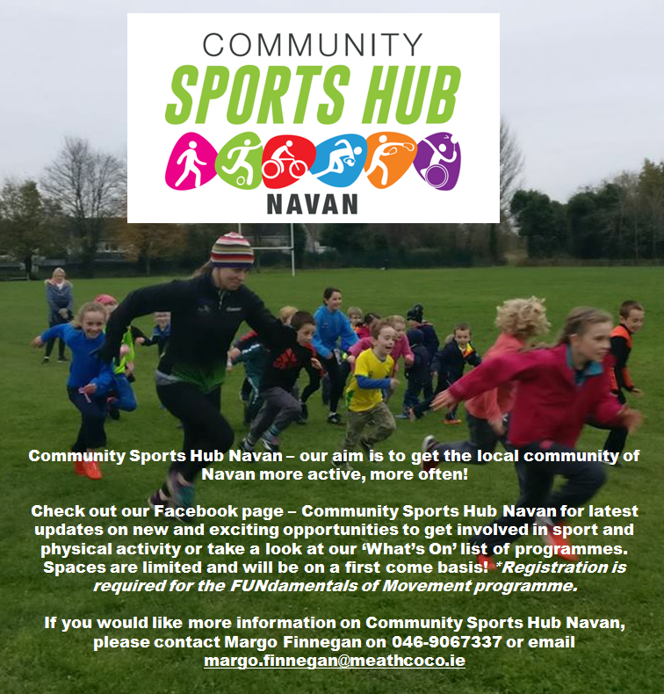

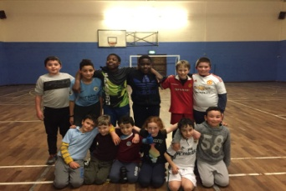
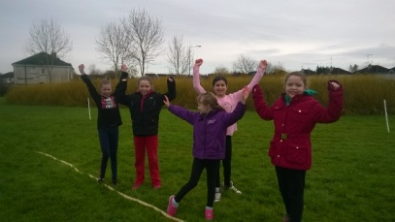
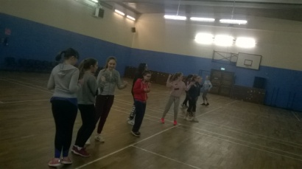

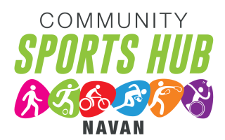
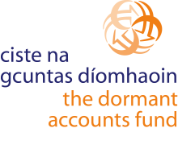
Community Sports Hub Navan – What’s On!
All programmes are FREE!

Programme | About | Time | Venue | Age | Date
MONDA
Fitsteps | Fun Fitness that is ‘Strictly’ dance - bring together Latin and ballroom styles into a fun fitness class. | 8-9pm | Unity Centre, Windtown | Over 18yrs | 6 weeks starting 9th April
TUESDAY
Buggy Buddies | Walking group open to parents and carers of babies and toddlers in buggies, prams or carriers! | 10-11am | Blackwater Park,  Ratholden Rd | Over 18yrs | 4 weeks starting 24th April
Cheer Dance | This class will focus on the basic fundamentals of cheer-leading, such as motion technique, dance, jumps, cheers and stunt technique and basic tumbling. | 4.30-5.30pm | Unity Centre, Windtown | 6-12yrs | 6 weeks starting 10th April
Mature Movers - Sit Fit | Seated exercise to music - are gentle and easy to follow exercises focusing on strength, mobility and balance. | 5.30-6.30pm | Unity Centre, Windtown | Adults +50 | 6 weeks starting 10th April
Run4Fitness | A mix of running and fitness training including mobility / flexibility and strength work. | 8-9pm | Blackwater Park,  Ratholden Rd | Over 18yrs | 6 weeks starting 10th April
THURSDAY
Couch to 5k | A beginner’s programme for anyone interested in reaching the 5k target whether it be by walking or jogging. | 9-10am | Blackwater Park, Ratholden Rd | Over 18yrs | 4 weeks starting 5th April
FUNdamentals of Movement *registration required please contact Kate Feeney 046-9067337 | This inclusive programme is aimed at children with disabilities and their siblings. Come along to join the fun and improve your running, jumping and throwing skills. | 5-6pm | Scoil Naomh Eoin, Clonmagadden | All Welcome | 3 weeks starting 3rd May
Basketball | Come and try Basketball sessions with qualified coaches. | 6-7pm | Scoil Naomh Eoin, Clonmagadden | 6-12yrs | 5 weeks starting 12th April
Basketball | Come and try Basketball sessions with qualified coaches | 7-8pm | Scoil Naomh Eoin, Clonmagadden | 12-17yrs | 5 weeks starting 12th April
Zumba | A Latin-inspired dance workout. Classes are fun, energetic, and make you feel amazing! | 7-8pm | Unity Centre, Windtown | 12-17yrs | 5 weeks starting 12th April
5-a-side soccer | Come as a group or individually. Everybody gets a game! | 8-9pm | Scoil Naomh Eoin, Clonmagadden | Over 18yrs | 5 weeks starting 12th April
FRIDAY
Late Night League - Futsal | Open to teams and/or individuals, all welcome to attend. | 8-10pm | Claremont Stadium, Commons Rd | 12-15yrs  16-18yrs | 4 weeks starting 20th April
SATURDAY
Multi Sport Activities | Come and try a range of different sports and activities. | 10.30-12.00pm | Bailis Downs - Johnstown | 6-12yrs | Once a month starting 14th April
Multi Sport Activities | Come and try a range of different sports and activities. | 10.30-12.00pm | Blackwater Park, Ratholden Rd | 6-12yrs | Once a month starting 28th April

