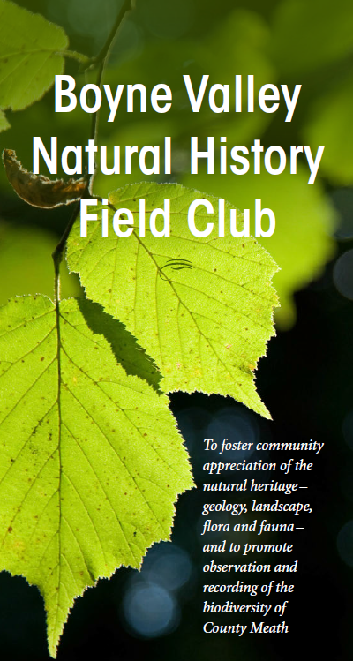
Boyne Valley Natural History Field Club 2018

Meath County Council in conjunction with the National Biodiversity Data Centre and Irish Wildlife Trust People for Bees project bring you the first of the bumblebee monitoring scheme workshops for 2018. On the day we cover all aspects of the monitoring scheme including species identification, use of the online data capture system and an afternoon outside putting the skills into practice. Hope to see you there!
To find out more details of the event please contact the main event organiser: Tomás Murray (tmurray@biodiversityireland.ie)
Date: Saturday, 28th April 2018

Time: 11:00 AM - 4:00 PM [GMT]

Venue: Dalgan Park, Navan, Co. Meath, Ireland

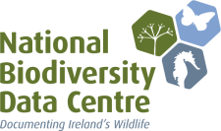

Monitoring Scheme

