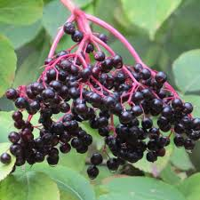
A Spring Day in Dalgan
Forty Shades of Green: Extolling the Wonder of Leaves
With Dr John Feehan
Saturday 14th April 2018, 9.30am – 3.30pm: (Registration 9.15am)
Venue
Columban Ecological Institute
St Columban’s, Dalgan, Navan, Co Meath

Our day begins with an introductory lecture, followed by an outdoor exploration of the wonder and adventure which spring offers within the grounds of Dalgan. Leaves will be our subject matter and extolling their wonder and beauty will be the focus of this exciting day. In the afternoon, we will look at our findings with the new eyes given to us by the microscope.

If you wish to attend, please contact Elizabeth Mc Ardle at devofficemail@gmail.com. Places for this day are limited due to microscope numbers and early booking is advised. The cost is €20, payable on the day. Participants are asked to bring a packed lunch, notebook and pen. Suitable outdoor clothes, rain wear and walking boots are all recommended. The day will go ahead whatever the weather.

