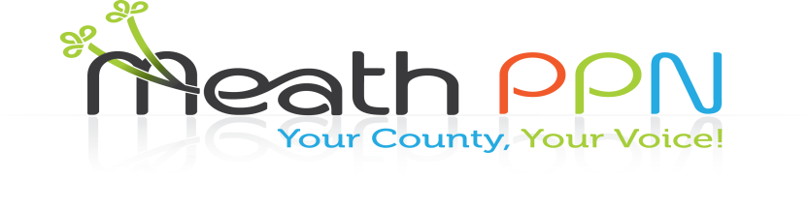

Plenary Update Wednesday 24th May 2017

|  |
| --- |
| **Update on issues register, workplan, secretariat:**  Keith Mulvey gave an update on the issues correlated from the Municipal District meetings and the focus for the secretariat over the next six months. The main focus over the next number of months for the secretariat will be the implementation of actions from findings of the waste survey, insurance costs for members, anti-social behaviour and community safety, promoting services for young people, creating more networking opportunities and promoting increased involvement in the decision making structures to address the issues highlighted at the MD meetings.  The workplan was presented to the members and a vote was taken and passed to ratify the workplan |
| **Waste Survey Presentation**  Conor Murphy from REDC presented the findings of the waste survey carried out in Meath. A full report will be published on the findings and presented to Meath Co. Co. |
| **Criteria & application process for defibrillators**  Details on the process for applying were presented. A communication will be circulated by Catherina to notify groups when the application process will be open and the documentation available on the website. |
| **Representation on committees and linkage groups**  Committee representatives from the Strategic Policy Committees, Local Community Development Committee and the Joint Policing Committee gave updates on the work carried out within each of these committees. The importance of involvement in the committees by PPN members was emphasized and Expressions of Interest Forms were handed out. |
| **Groups and feedback**   * Issue of illegal dumping, lack of enforcement by the Local Authority and limited availability of dog waste bins and recycling bins * Increased surveillance through the instalment of more cctv in designated areas was suggested as both a deterrent for illegal dumping and ant-social behaviour * Focus on how the cost of insurance can be reduced for groups and identify insurance companies offering good value insurance to groups * Comment from PPN member on funding from the HSE that has not been released * Suggestion to introduce bye-laws on the use of cycle lanes * New transport service will be introduced by Flexi- Bus * The valuable contribution that volunteers make to their communities and the local authority was noted * Focus on ensuring that the existing agreed policies within Meath Co. Co. are implemented for communities |
| **AOB:**  Photos will be published on Facebook any objections please let Catherina know  Reminder closing date for Pride of Place Applications 2nd June 2017  Funding for projects/initiatives to increase Environmental Awareness in the Community  Capital Facilities Grant scheme closing 30th June  New Public Consultation Platform being set up[**consult.meath.ie**](http://consult.meath.ie/) |
| **Close and Draw:**   * Congratulations to the prize winners of a voucher for an overnight in the Knightsbrook with dinner and the voucher for dinner in the Newgrange. * A big thank you was extended to all those who attended the meeting and to all involved in a voluntary capacity within their communities |